

Nature. Water.

ENGLISH 3 “

Vereshchagina

I.N.,

Pritykina

T.A”

Выполнила учитель английского языка

Можжерина

Е.А.



Let’s sing the song

A sailor went to sea, sea, sea

To see what he could see, see, see.

But all that he could see, see, see

Was the blue, blue sea, sea, sea



Английские омофоны

Pay attention!

Try to remember!

Sea

≠ See

(

море

)

≠ (видеть)

Sail ≠ Sale

(

плыть под парусом) ≠ (распродажа

)

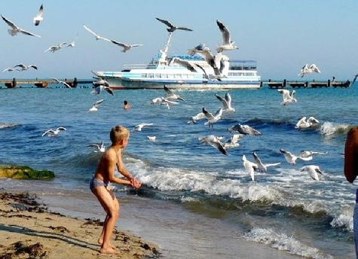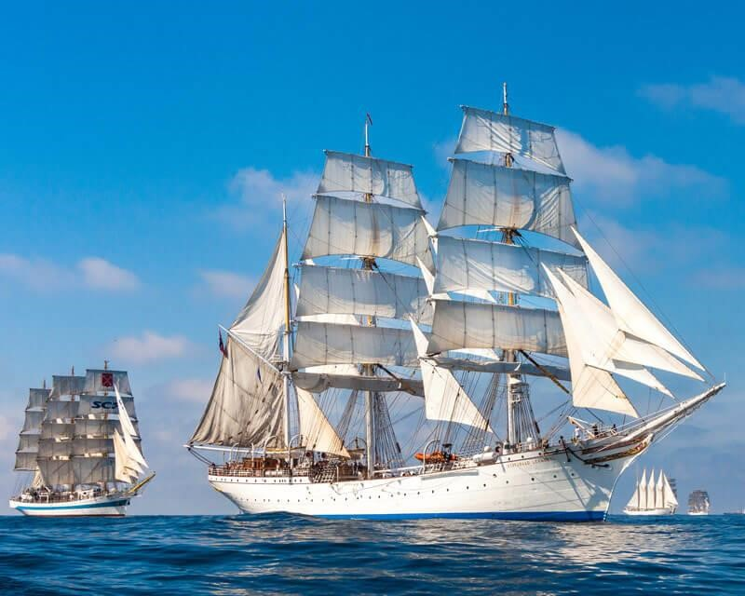

Try to continue the sentence

A man who can swim is …

A man who can sail is ….



Check yourself and translate

A man who can swim

is

SWIMMER

A man who can sail is

SAILOR

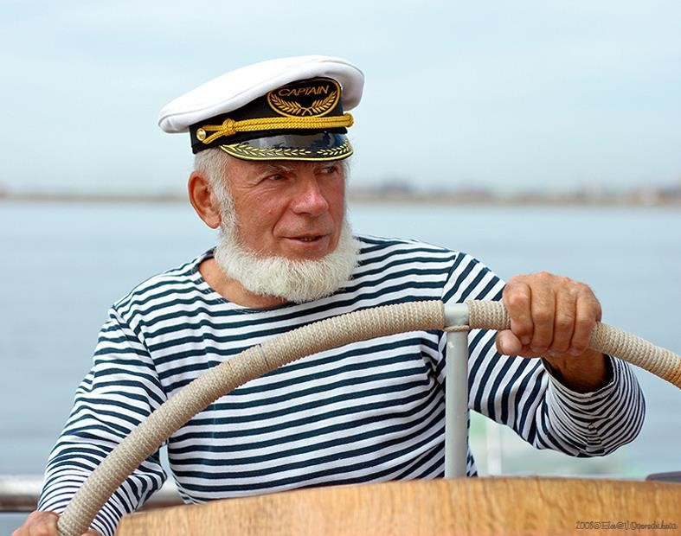

Translate the phrase

“Anybody can pilot a ship,

when the sea is calm”



What are we speaking about ?

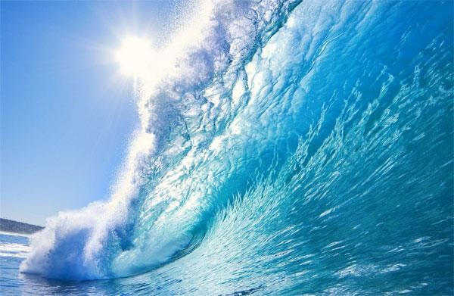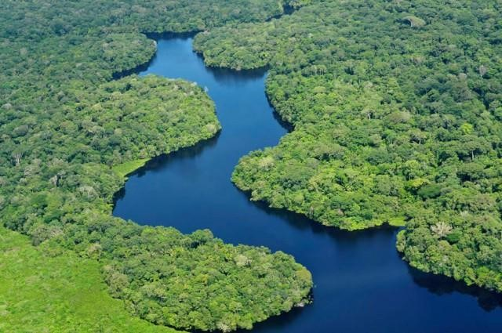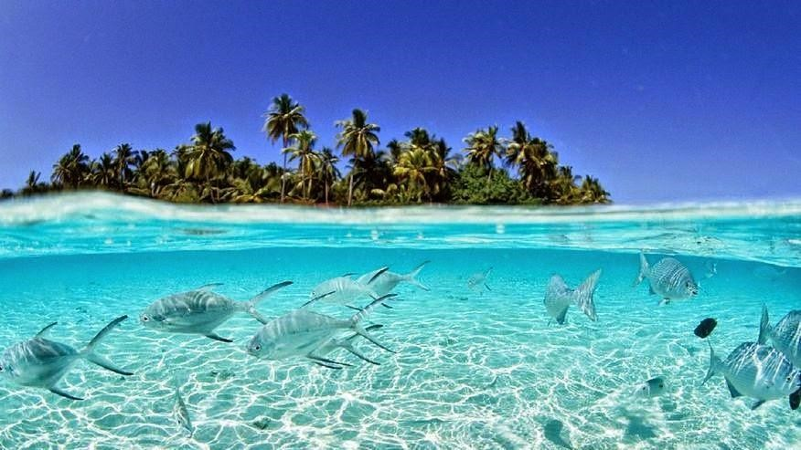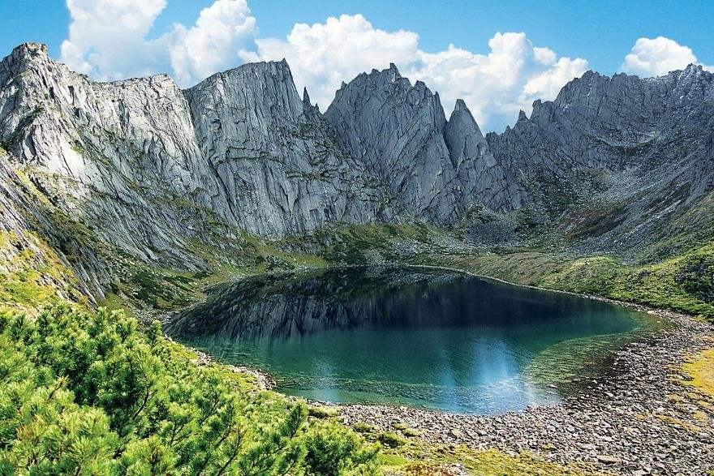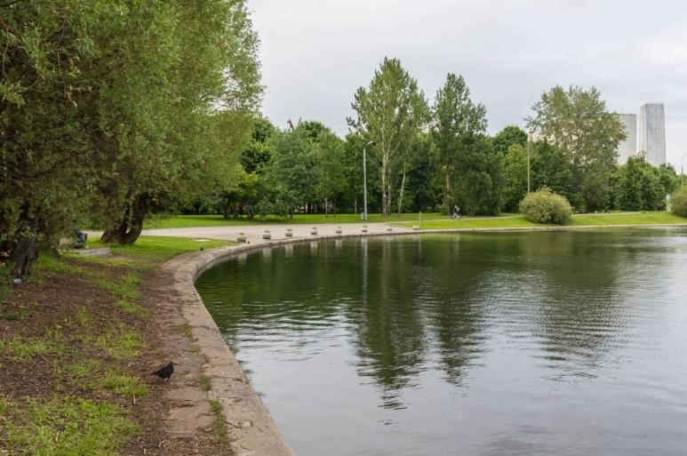

ocean

river

sea

lake

pond



Compare two rivers:

This river is … than that one.

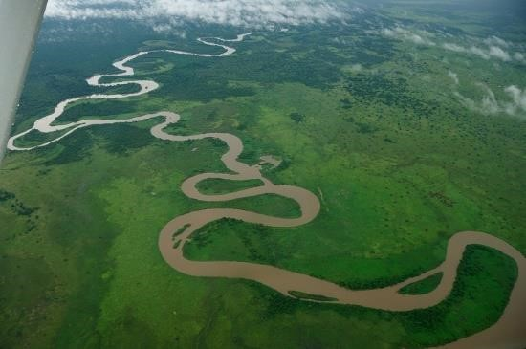

This river is … than that one.



long

short



Compare two oceans:

This ocean is … than that one.

This ocean is … than that one.

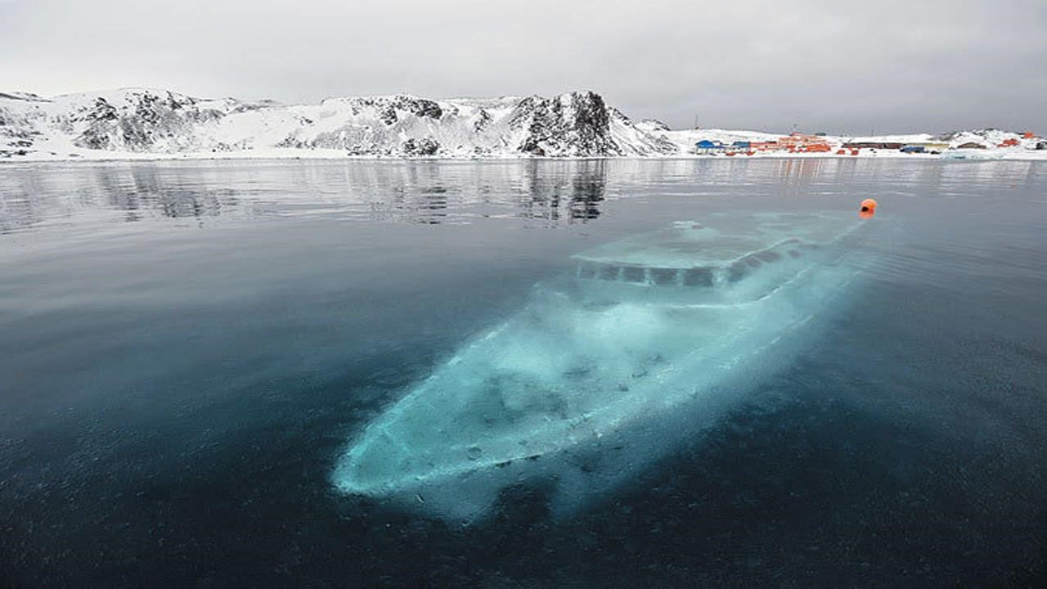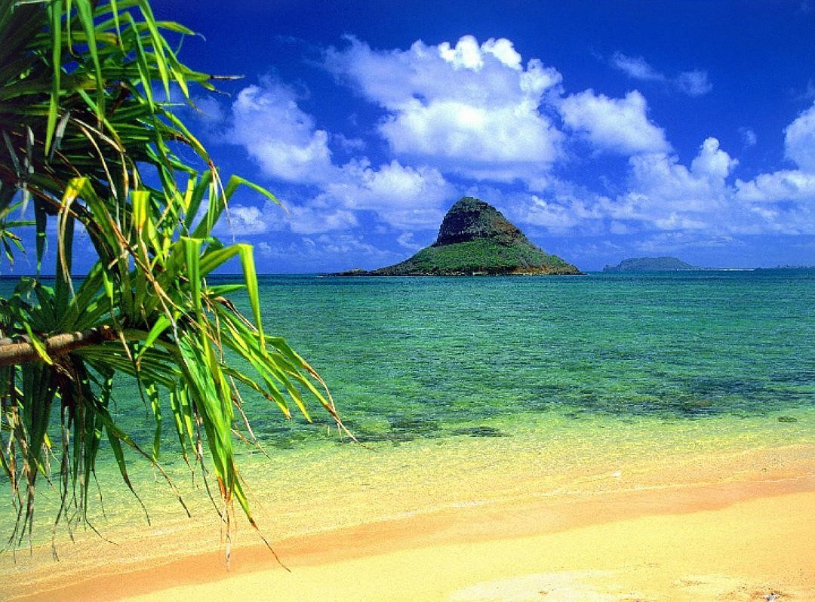

cold

warm



Compare two lakes:

This lake is … than that one.

This lake is … than that one.

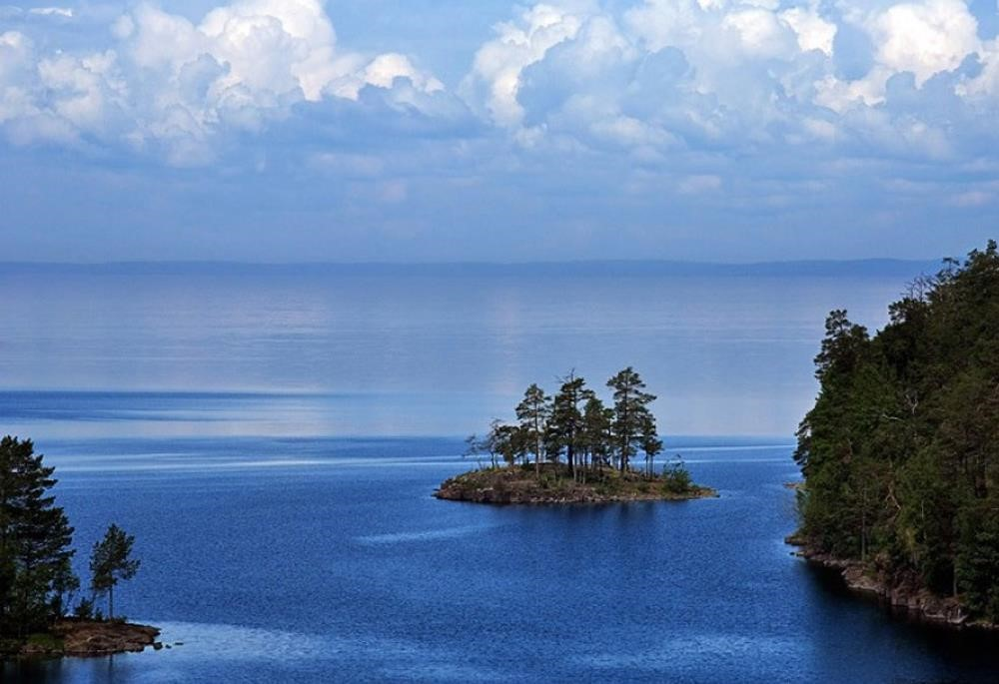

big

small



Compare two seas:

The Red Sea is … … than the Black Sea.

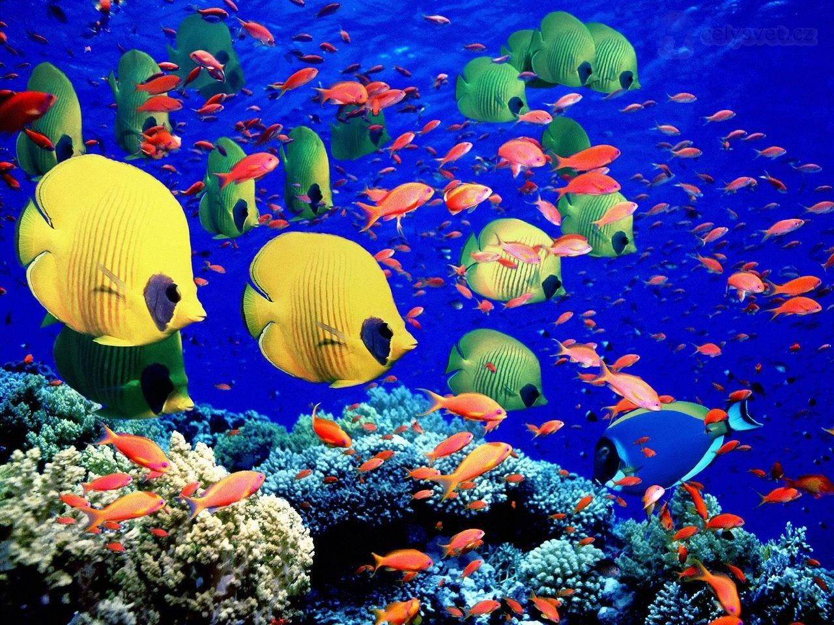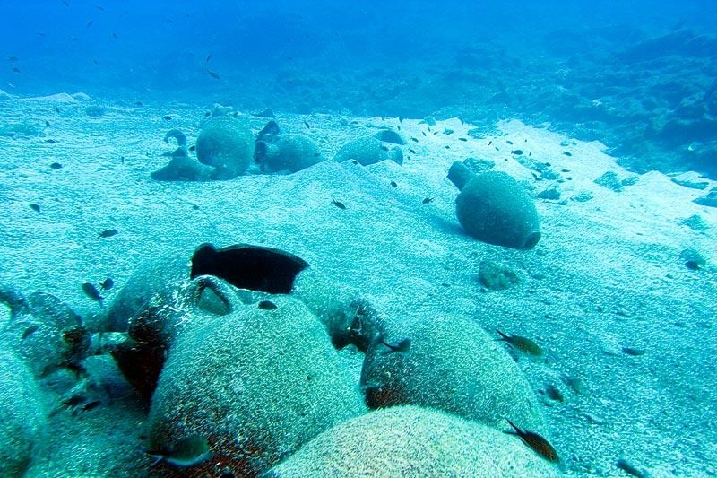

The Red Sea (beautiful) The Black Sea

Check yourself:

This river is longer than that one. This river is shorter than that one.

This ocean is colder than that one.

This ocean is warmer than that one. This lake is bigger than that one. This lake is smaller than that one. The Red Sea is more beautiful than the Black Sea.



What tense are we going to use in our

speech today?

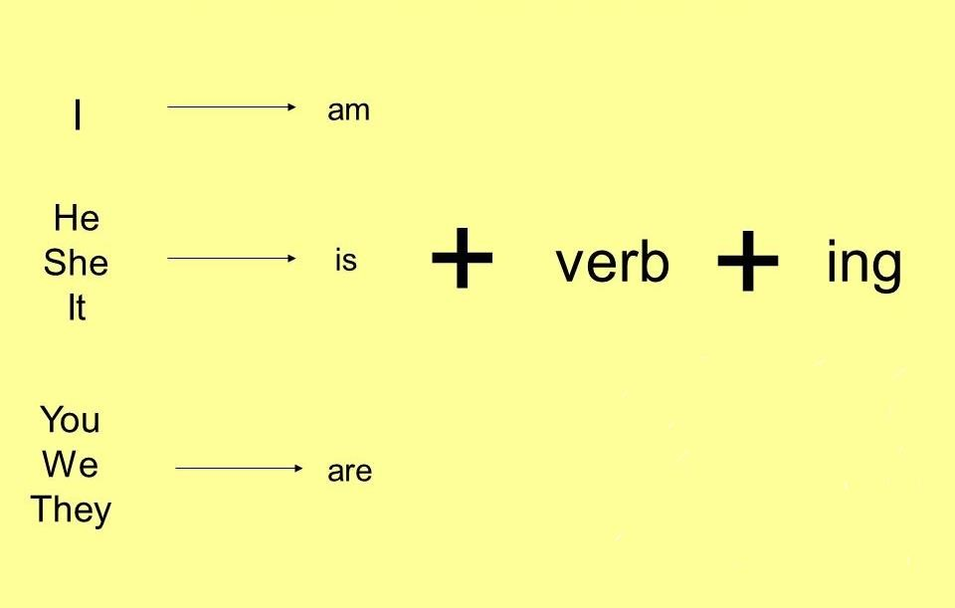

It is Present Continuous (Progressive)

tense

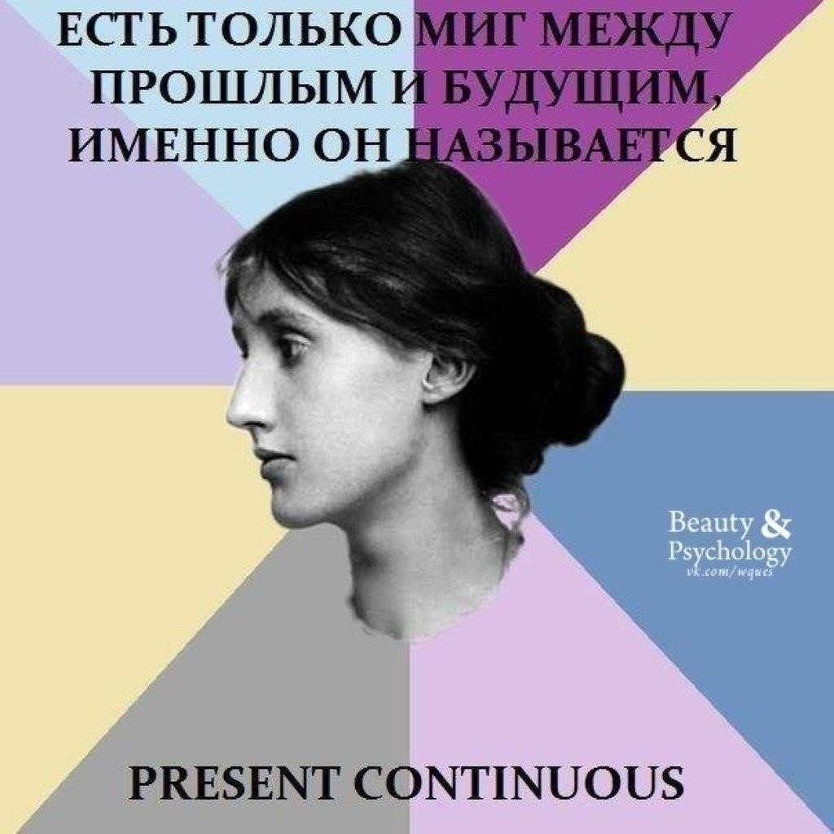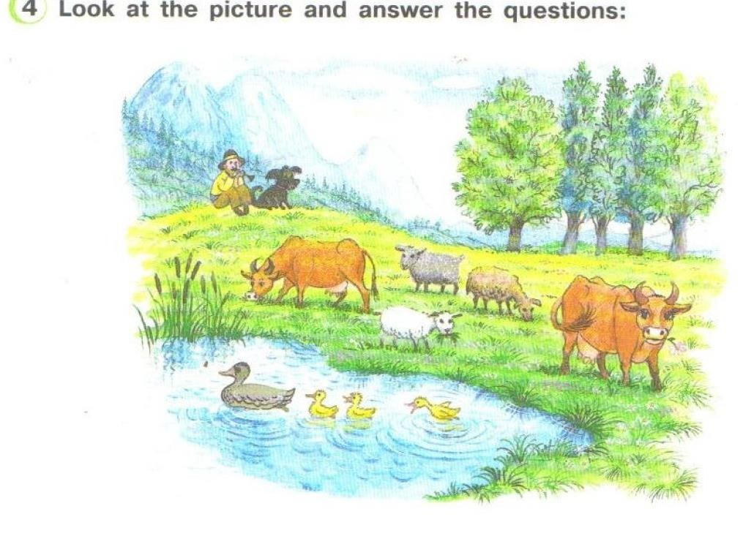

1

What is near the lake?

2

What is near the field?

3

Whom can you see in the field?

4

What

colour

is the dog?

5

What

colour

is the lake?

6

What

colour

are the ducks?

7

What season is it?

8

What is the man doing?

9

What are the caws doing?

10

What is the dog doing?

11

What are the ducks doing?

12

What are the sheep doing?

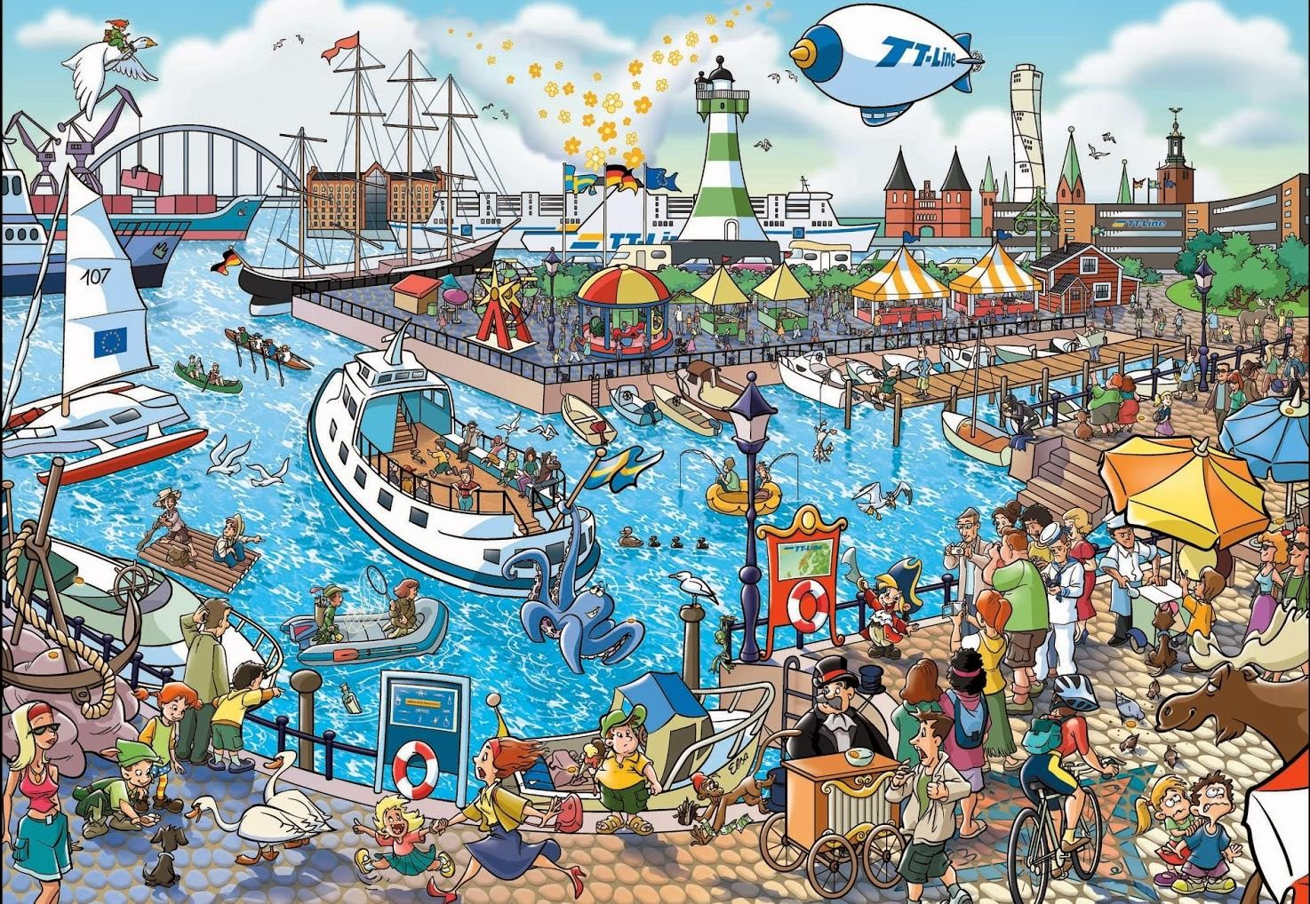

Describe the picture:



Write down the translation of the

words you’ll listen to.



Listen and guess! Which picture are they speaking about?

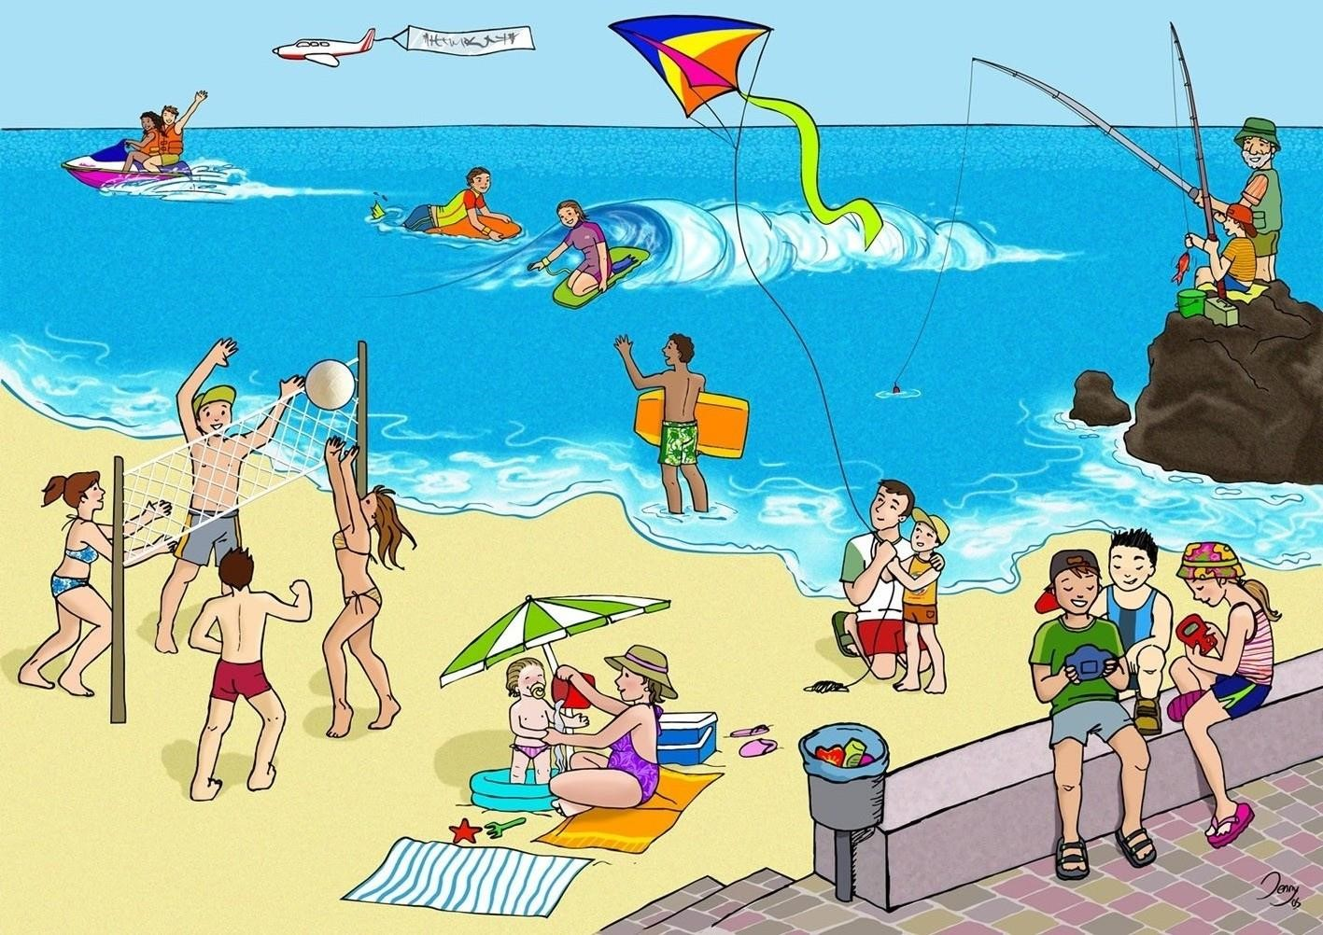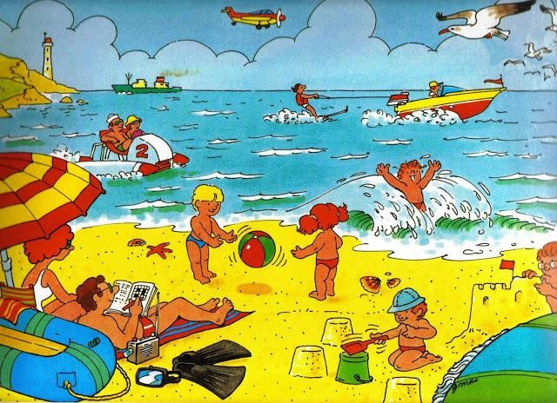

Picture 1 Picture 2



Thank you for the lesson. Please write

down:

1

How many words have we learnt today?

2

What was the more difficult for you?

3

Count your smiles











Home task:

Student’s

Book P 114 ex

8

l

earn by heart new words