Автор: Сиволапова Римма Александровна
Место работы, должность:
МБОУ ТСОШ № 2, учитель английского языка
Регион:
Ростовская область
Уровень образования: Среднее общее образование
10 класс

Предмет: Английский язык
Тема урока: «Досуг молодежи. Развлечения современных подростков».

Цель урока: развитие коммуникативной компетенции учащихся на основе изученных лексических единиц, речевых и грамматических структур по теме модуля “Развлечения”, входящей в тему экзаменационного материала в кодификаторе: «Свободное время».
Задачи урока:
Познавательный аспект:
- знакомство с популярными способами проведения досуга подростков в англоговорящих странах
Образовательные:
- формировать языковые, речевые и коммуникативные компетенции при развитии и контроле сформированности компетенций аудирования, чтения, и говорения;
- активизировать употребление в речи ранее изученных лексических единиц по теме «Досуг молодежи. Современные подростки.»,
- совершенствовать и расширять навыки выражения своего мнения по теме;
Развивающие:
- активизировать учебно-познавательную деятельность учащихся и расширить их кругозор;
- развитие способности к выявлению языковых закономерностей, развитие и автоматизирование лексических навыков по теме
- развивать навыки успешного самостоятельного решения проблемы;
- развивать умения социального взаимодействия;
- развивать критическое мышление учащихся;
- развивать эмоциональную отзывчивость.
Воспитательные:
- воспитать активность, самостоятельность, ответственность, культуру общения;
- формировать мировоззрение учащихся и логическое мышление;
• формировать систему нравственных межличностных отношений, навыки работы в творческой группе;
- формировать доброе отношение друг к другу.
- повысить мотивацию к изучению английского языка.
УУД: Коммуникативные:
- проявление активности во взаимодействии для решения коммуникативных и познавательных задач;
Познавательные:
- выявление достоверной (противоречивой) информации в процессе работы с одним или несколькими источниками;
Регулятивные:
- выбор учебных действий в соответствии с поставленной задачей и условиями её реализации; адекватное восприятие исправления ошибок;
- оценивать правильность решения учебной задачи, собственные возможности;
Личностные:
- оптимизм в восприятии собеседника;
-позитивная моральная самооценка;
- навыки сотрудничества в разных ситуациях общения.
Тип урока: Комбинированный урок
Оборудование: УМК Spotlight 10 (В. Эванс, Д. Дули, О. Афанасьева, И. Михеева)
Компьютер, интерактивная доска, мультимедийный проектор, компьютерная презентация к уроку, раздаточный материал, видео.
Применяемые технологии: Технология коммуникативного обучения иноязычной культуре, использование эмоционально и когнитивно-ориентированных форм обучения, игровая технология.
Формы работы: индивидуальная работа, парная работа, групповая работа, фронтальная работа.
Методы обучения: объяснительно-иллюстративные; частично-поисковые, проблемно-эвристические.
Источники информации: «Английский в фокусе» Афанасьевой О. В., Дули Д., Михеевой И.В., Эванс В., Оби В., УМК входят учебник, рабочая тетрадь, книга для учителя, книга для чтения, языковой портфель, CD для работы в классе, CD для самостоятельной работы, CD-ROM диска, веб-сайт курсаwww.spotlightonrussia.ru, сборник контрольных заданий
Учебно-методическое обеспечение: Английский язык: Учебник: Английский язык. Английский в фокусе. 10 класс. / О.В. Афанасьева, Дж. Дули, И. В. Михеева, В. Эванс. - М., Просвещение. -2017
Используемая методическая литература:
- Прищепа Т.А Некоторые аспекты проблемно-эвристической дидактики и методики или как построить урок открытий. – Томск: ТОИПКРО, 2008.
- Учебник: Английский язык. Английский в фокусе. 10 класс. / О.В. Афанасьева, Дж. Дули, И. В. Михеева, В. Эванс. - М., Просвещение. -2017

- книга для учителя, книга для чтения, языковой портфель, CD для работы в классе, CD для самостоятельной работы, веб-сайт курса www.spotlightonrussia.ru
- Прищепа Т.А Некоторые аспекты проблемно-эвристической дидактики и методики или как построить урок открытий. – Томск: ТОИПКРО, 2008.
- Интернет- ресурсы:
www.notsoboringlife.com/popular-hobbies/
http://www.youtube.com/watch?v=YMTRr4_qNdw
https://www.youtube.com/watch?v=nMFrC3UGtekhttps://www.youtube.com/watch?v=Qkxj2Rslljc

Ход урока.

I.Организационный момент. Мотивация к учебной деятельности.
Good morning, children. Good morning, dear guests! Welcome to our lesson. I’m glad to see you. How are you? Sit down, please.
(Уч. Good morning, teacher! We are glad to see you too.)
Please, children, look at the pictures on the blackboard and listen to the information about it. (Аудио Ex. 1.b p. 122. What do the pictures show? What will we have a talk about today?
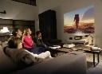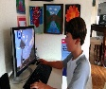
(We will talk about leisure of youth, free time of modern teenagers)
Let`s talk about modern teenagers.
1.How do you think is it easy to be young? (I think teen`s life is not easy because many problems are associated with them)
2.What can make teenagers happy? (Young people can choose some way of life they want)
You are right. The pictures show what young people do in their free time. Today we are going to talk about our modern teenagers. Is it interesting to learn how they spend their free time? Is it necessary to know? (Yes it is. I think it`s necessary.)
Why should you know about leisure of teens from different countries?
Is it interesting to learn about leisure of teens from different countries? (Yes it is. As for me it`s interesting.)
So. What is the theme of our lesson? What is the problem of our lesson? (The theme of our lesson is “Leisure of youth. Modern teenagers` entertainment.”)
II. Целеполагание.
What are the aims of our lesson?
The aims of our lesson are
1. To read, listen, find out the information about different forms of teenagers` entertainment.
2. To be able to ask questions about leisure of youth.
3. To talk about free time of teenagers from different countries.
4. To express your opinion about modern generation with square eyes.
5. To be able to write notes about how teenagers entertain themselves, describe photo with them.
III.Актуализация опорных знаний. (Фронтальный опрос)
What do you know about entertainment?
  - Фонетическая разминка.
First of all some phonetic exercises. Look at the black board and pronounce the sounds and words. Please, explain the meaning of these words\phrases in bold.
([ ]- anti-social (not friendly), catchy (easy to remember), addict (who likes an activity very much),
[eu] – Couch-potatoes (people who spend a lot of time sitting and using a computer or watching TV)
[ ] – unfair (not right), unwind (relax)
[ee] – blaring (making a loud noise)
[ i] – sing along (join in and sing with others), predictable (obvious what is going to happen), gripping (wonderful)
[ e ] – incredible (amazing)
[ o ] – malls (large shopping centers)
  - Речевая зарядка.
1.How are some modern teenagers called?
2.Who can make a formulation of the problem? (Some modern teenagers are called couch potatoes or generation with square eyes.)
3.Why do you think they are called that? (I think the term “square-eyed generation” means teenagers who do nothing else but watch television)
4.Do you agree with …...? (I agree with …. I think it describes today`s teens, as they watch a lot of television and spend a lot of time using computers

IV.Основной этап урока. Работа по теме урока.
- Развитие навыка поискового чтения. (Работа в парах)
All right, children. Open your books p. 122 Ex, 4. Look through the text and say about different forms of teenagers` entertainment.
-What do children say about entertainment? Ask some questions and tell about it.
Let’s work in pairs. One of you will ask about entertainment of teenagers, the other person should tell about his\her partner’s activity. Mind the grammar changes in the sentences with the third person.
(1. What does Suzy say about entertainment? (She says it`s a way to relax. Suzy says that she likes to unwind on a Friday night with a good DVD, but one of her favourite things to do is go dancing at the famous London club “Ministry of Sound”.
-Where is she from? (She is from the UK)
2. What does Maria say about television? (Maria says it`s catchy.)
Prove from the text.
(Maria says that many Mexican teenagers do spend too much time watching TV, especially soap operas.)
- What does Yoko say about leisure of youth?
(Yoko says that he likes to go out to “karaoke” with his friends. Where they can sing along to all the latest music) Where is he from? (He is from Japan).
- What does Sanjit prefer to do in his spare time? (Sanjit says that he prefers to go to the cinema to see “Bollywood” movies. He is from India.
- What does Ann say about herself? She is from Russia. ( Ann says that she is a bit of a video game addict.)
What have you known from this text? How do you think is it necessary to know about it? Why?
-Good of you, boys and girls. I think you`ve learnt a lot of useful information. Check your work. please, in the self-assessment sheet.
2. Активизация грамматических навыков. (Работа в тетради)
As you know free time activities can be divided into 3 groups, we use the verbs: do, play, go. Can you add more activities to each category? Tell me, please, about children`s activities.
(на доске опора, слайд: know free time activities can be divided into 3 groups: do, play, go)
- Why should you remember the possessive case and reported speech?
(Remember 1. the Possessive case. _______ `s… is
- Reported Speech: Present Simple V1------- Past Simple V2
«He\ She prefers to …» -------- He\She said she\he prefered to …
Open your copybooks, write the date in your copybooks, please, and write notes about how teenagers entertain themselves choosing a verb from groups
(Change, please, from direct to reported speech, using this structure)
(1. Suzy`s activity is according to category where we use the verb: go, because she said she prefered to go dancing to the famous London club.
2. Maria`s activity is according to category, where we use the verb: do, because she said she prefered to watch TV.
- Yoko`s activity is according to category, where we use the verb: do, because he said he prefered to sing along with his friends.
- Sunjit`s activity is according to category where we use the verb: go, because he said he prefered to go to the cinema.
- Anya`s activity is according to category, where we use the verb: play, because she said she prefer to play computer games. )
Your answers are very good. Check your work, please, in the self-assessment sheet.
3. Физминутка. Развитие навыка аудирования с целью основного понятия содержимого.
Now let’s rest and play a game: «Musical stick”. You should listen the piece of music, passing the stick. On someone will stop the music should guess the kind of music. Then try to answer the question: "Where could you hear it? (in the theater?, in the cinema?, on TV?, in the street?, at a café?, or in the car? on radio?)
(на слайде опора: Possibility
could + present infinitive: possibility in a specific situation)
- It`s a pop music. I think I could hear it in the cinema and TV.)
- It`s a classical music. I think I could hear it in the theatre)
- It`s a rock music. I think I could hear it on the TV, radio and in the addicts` cars)
- It`s a juzz music. I think I could hear it on the TV, radio.)
I think you could hear all kinds of music in the tracks of different movies. Is it true? (Yes it is, it`s true). You are doing well.
V.Первичное закрепление лексических единиц и грамматических явлений.
1. Развитие лексических навыков. (Работа с карточкой)
Speaking about our preferences, we can use different words and phrases. Let’s write about teenagers` activities using these words. Fill its in the correct form. Work with cards. Take it, please and write your surname and name.
Fill in: unwind, beat, sing, book, direct in the correct form.
  - I love going dancing on a Friday night. Nothing …… that.
  - Have you already ……. the tickets for the theatre tonight.
  - Steven has ……. many films. It`s one of them.
  - He sometimes watches TV in the evenings to relax and …..
  - It is such a catchy tune you can`t help but ….along.
(1 beats, 2 booked, 3 directed, 4 unwind, 5 sing)
So verify each other, please, your classmates` work and mark it. Give me, please, your cards. You should remember your answers and check your work, please, in the self-assessment sheet.
VI. Развитие навыка устной речи. 1.Развитие навыка комбинированного диалога. (Работа в группах).
I see you know how modern teenagers with square eyes use leisure time. Split into two groups of 7 and learn what’s the most popular activity in your group. What entertainments do you like? Why? Ask any classmate from the opposite team about it and tell him about yourself. But at first I suggest watching a video, please, which help you to tell about leisure of youth and some forms of entertainment.
(Задают вопросы противоположной команде по очереди и отвечают на вопросы другой команды и говорят немного о своем свободном времени.)
- I prefer feature films. I find them entertaining. Sometimes I enjoy going to malls with my parents. Vadim, how many hours do you spend at home?
- I spend 5-7 hours at home. I like music. I prefer going to the musical club twice a week. I find it exciting. Ann, what is your favourite television program?
- I like program about cooking. I find it more useful than other programs. Nariner, do you like watching about discoveries?
- No, I don’t. I prefer comedy films. It`s such a good laugh. I find them gripping. However, my favourite thing is sing along with my friends at school after lessons. Igor, how many times in a month do you go to the cinema?
- I go to the cinema once a month. But I enjoy watching documentaries, science fiction. I find them educational. It can raise my level of a culture. What about you, Victoria?
- I enjoy reading books and doing sports in my free time. It helps me to be healthy, more organized and strong.
2.Развитие навыка монологической речи. (Монологическое высказывание по плану). (Индивидуальный опрос)
These are photos from your photo album. Choose one photo to describe to your classmates.
You will have to start speaking in 1.5 minutes. You have to speak for 2 minutes or less. Remember to talk about:
- where and when the photo was taken;
- what/who is in the photo;
- what is happening;
- why you keep the photo in your album;
- why you decided to show the picture to your friend.
You have to talk non-stop starting with:
I’ve chosen photo number....
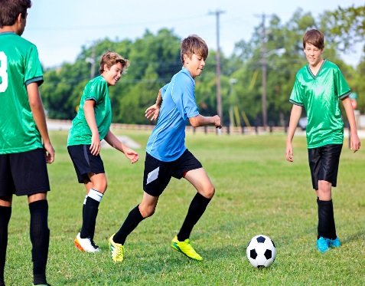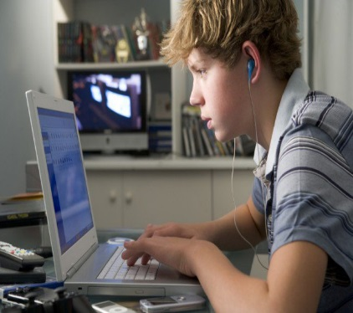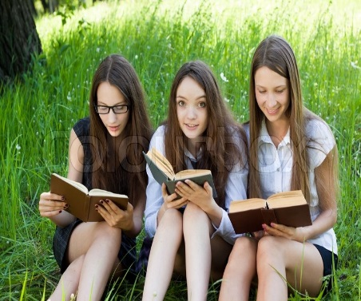
(Образец описания фото № 3)
1. I've chosen photo number 3. You know, taking photos is my hobby, and I always take a lot of photos wherever I go. I took this photo last summer in the park not far from our school.
2. In the photo you can see three girls reading books. The day is nice, it is sunny. You can see a park with tall green grass and trees. There are some girls in the centre of the picture — they are all my classmates: Lera, Julia and Nariner. They are pretty.
3. Girls wear school uniform. They did not have time to change their clothes after lessons. They all look very happy and excited as they are reading together in a fresh air. They are preparing to pass the exam in Literature.
4. I keep this photo in my family album, as it is very dear to me. It was actually a very memorable day when our big family got together and I could meet all my sisters and brothers and enjoy time together.
5. I decided to show this photo to my friend because I’m glad to see my classmates and happy that they get together from time to time. I hope you liked it.
Well-done. I`m very pleased with you.
Write down the homework in your notebook. Describe the picture Ex.1 p. 124, using this plan. Lera, please, take a picture of this plan and give it to the conversation online in contact.
Kids, verify, have you got the message? (Yes, I have)
VII.Рефлексия.
To sum up our lesson, what have you learnt at the lesson?
- I have learnt to say about teenagers` comments, their free time.
- I have learnt to make some new phrases about leisure of youth.
- We have known other forms of entertainment.
- I have learnt to divide free time activities into 3 groups.
- I have learnt to make notes about leisure of youth.
- I have known about modern teenagers – generation with square eyes.
- I can speak about my free time.
- I can describe photo with people and their activities.
In conclusion, I`d like to say it`s very amazing to do useful things in your leisure time. It help us to learn more about our planet, to be more intelligent and well educated. . Check your work, please, in the self-assessment sheet. What marks have you given yourself? You worked very hard. Your answer was wonderful. I agree with your mark. I think you are doing well but you should work harder. That`s why you`ve got 4. You`ve made a lot of mistakes. I`ve given you three. The lesson is over. Thank you for taking an active part in it. Good-bye.
