Министерство образования и науки Республики Татарстан

Государственное автономное профессиональное образовательное учреждение

**«Набережночелнинский педагогический колледж»**

**РАБОЧАЯ ТЕТРАДЬ**

**ПО ДИСЦИПЛИНЕ ОУД.03 ИНОСТРАННЫЙ ЯЗЫК**

**(АНГЛИЙСКИЙ)**

**ДЛЯ СТУДЕНТОВ 1 КУРСА**

**специальности 44.02.02 Преподавание в начальных классах**

**Преподаватель английского языка**:

Фазлыева А.А.

Набережные Челны

2022

**Содержание:**

Пояснительная записка 3

Unit 1. My life 4

Unit 2. Travelling 6

Unit 3. City life 7

Unit 4. People 9

Unit 5. Work 11

Unit 6. Leisure. Activities 13

Unit 7. Food 14

Unit 8. Home 17

Unit 9. Seasons 18

Unit 10. Culture 21

Unit 11. Music 24

Список используемой литературы 27

**Пояснительная записка**

Рабочая тетрадь предназначена для студентов 1 курса педагогического отделения, поступивших в [колледж](https://pandia.ru/text/category/koll/) на базе основного общего образования, имеющих недостаточно высокий базовый уровень знаний, умений и навыков по [иностранному языку](https://pandia.ru/text/category/inostrannie_yaziki/).

Цель рабочей тетради – помочь учащимся понять основные грамматические структуры английского языка, а также способствовать развитию речевой профессиональной деятельности на английском языке. Реализация этой цели осуществляется благодаря специально подобранным аутентичным текстам, языковым и речевым упражнениям, которые способствуют формированию у обучающихся коммуникативной компетенции в профессиональном общении. Тексты тематически связаны со специальными предметами, изучаемыми на этом курсе, отражают специфику будущей профессии.

Рабочая тетрадь включает в себя 11 тематических циклов, в каждый из которых входят текст, лексические и грамматические упражнения. В конце рабочей тетради представлены тесты по всем разделам грамматики, изученным за период первого курса.

Рабочая тетрадь соответствует требованиям ФГОС, а также содержанию рабочей программы учебной дисциплины ОУД.03 Иностранный язык и календарно – тематическому плану дисциплины; предназначена осознанному и прочному усвоению учебной информации.

**UNIT 1. MY LIFE**



**1.Read and translate the text.**

**About Myself**

My name is Marina Suvorova. I am 15. I was born on the 5th of March, 1985 in Rostov-on-Don. Now I live in Rostov with my parents and my grandmother.

My family is not very large. We have five people in our family. My father`s name is Igor Petrovich. He is forty years old. He is a doctor and he works at a hospital. My mother`s name is Lyudmila Leonidovna. She is thirty - nine years old. She is a housewife. My younger sister is a pupil. She is in the seventh form. My grandmother lives with us. She doesn’t work. She is a pensioner. I love my family. We are all friends and we love each other.

I am a student of the college now. We have many good teachers at our college. I try to be a good pupil and I do well in all subjects. But my favourite subject is English. I spend much time on it.

I have many friends. We spend much time together, go for a walk, talk about lessons, music and discuss our problems.

I like to listen to modern music, but sometimes I like to listen to some classical music. My favourite composer is Tchaikovsky. I haven`t much time to watch TV but sometimes I spend an hour or two watching an interesting film or a news programme. In the evening I often read an interesting book. I like fresh air and exercises, but I have not much time to go in for sports.

**2. Answer the following questions**

·  Is Marina’s family large?

·  How old is she and her parents?

·  What are her parents?

·  Has Marina got any brothers or sisters?

·  Marina is a college student now, isn’t she?

·  What is Marina’s hobby?

·  What does she do in the evening?

·  Does Marina like to go in for sports?

**3. Write these words in plural**

|  |  |  |  |  |  |
| --- | --- | --- | --- | --- | --- |
| Month |  | Man | Son |  |  |
| Eye |  | Bridge | Factory |  |  |
| Ear |  | Bush | Basis |  |  |
| Brother |  | Airman | Boy |  |  |
| Deer |  | Chimney | Box |  |  |
| Army |  | Formula | Tooth |  |  |

**4. Match the words 5. Match the job with the picture**

|  |  |
| --- | --- |
| a daughter | Жена |
| a wife | Племянница |
| a husband | Тетя |
| an uncle | кузен (кузина) |
| an aunt | Жена |
| a nephew | Дочь |
| a niece | Муж |
| a cousin | Дядя |
| a daughter | Дочь |
| a wife | Племянник |

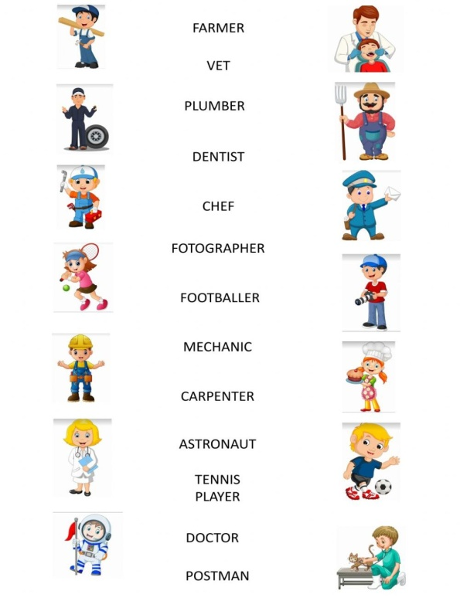

**6. Insert *am, is, are*.**

1. He … a student. 2. Fred … not angry. 3. My friend … kind. 4. Her name … Mary. 5. She … a nice girl. 6. We … pupils. 7. His name … Tom. 8. I … seven. 9. Rex … brave and kind. 10. They … friends. 11. You … happy. 12. Her name … Bess. 13. She … nice and merry. 14. Kate … not lazy. 15. Her name … Jill. 16. She … seven. 17. He … a nice boy. 18. His house … nice. 19. Tim … slim and sad. 20. He … happy. 21. I and Tom … friends. 22. Nick … strong. 23. Tom … smart. 24. Mr. Greenwood … nice. 25. His pet … funny. 26. Bob … strong. 27. It … black. 28. I … a pupil. 29. My friend … brave. 30. You … sad. 31. They … strong. 32. Pete … nine. 33. Our cat … five. 34. She … seven. 35. They … ten. 36. My name … Kate. 37. I … six. 38. I … not a pupil. 39. My dog … grey. 40. His cat … black and white. 41. My pets … funny. 42. I … Dino. 43. My friend … strong and healthy. 44. Billy … fat. 45. We … in the park. 46. Crocodiles … green. 47. Her shirt … not dirty. 48. I … not big. 49. Dino … not a teacher. 50. Pupils … lazy. 51. Tiny … kind and funny. 52. I … seven. 53. You … a pupil. 54. Tom’s birthday … on the 8-th of July. 55. Tom … from Great Britain. 56. My pets … funny. 57. The girl’s flowers … nice. 58. I ... a student. 59. My father ... not a shop-assistant, he ... a scientist. 60. ... your aunt a nurse? - Yes, she ... . 61. ... they at home? - No, they ... not. They ... at school. 62. ... you an engineer? - Yes, I.... 63. ... your friend a photographer? No, she ... not a photographer, she ... a student. 64. ... your brothers at school? - Yes, they ... .

**7. Write 12 sentences about yourself and your family**

**8. Make up a dialogue «Acquaintance»**

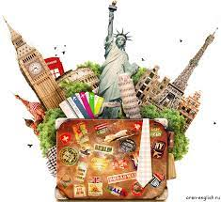**UNIT 2. TRAVELLING**

1. **Correct the sentences**

She my favourite teacher.

She name is Kate. Mark are from Paris.

I from Moscow. What your favorite city?

Nice meet you. I from Kazan.

Where is you from? Who is your address?

You is my teacher. Where your book is?

What your name? She my sister.

I not understand. How old you are?

She is America. You is an accountant.

Welcome Russia. This are your husband.

My wife very beautiful. Olga 49.

**2. Make negative and interrogative sentences with these words using *to be***

Interesting, beautiful, old, modern, teacher, bad, good, popular, London, country

**3. Match the words with their meanings.**

Commuting full of people

Suburbs travelling to work every day

Park the busiest time of day

Rush hour leave a car somewhere

Crowded places around a city where people live

**4. Put the following words into the correct column:**

Airport, car, drive, flight, garage, journey, park, passenger, plane, platform, station, ticket, traffic, train, bicycle, bus, motorbike.

|  |  |  |
| --- | --- | --- |
| **air** | **Rail** | **Road** |
| Airport | Platform | Car |

**5. Match the direction with the map 6. Read and translate the text.**

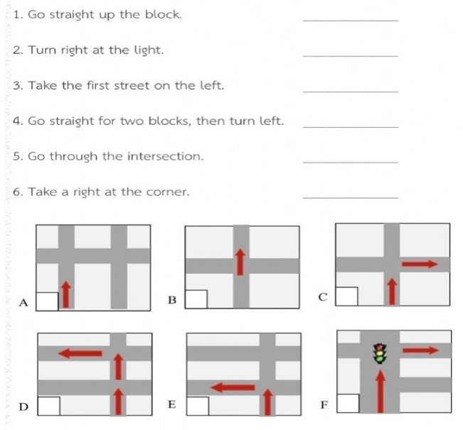**Travelling**

Travelling became a part of our life. Thousands of people travel every day either on business or for pleasure. They travel by road, by train, by air or by sea.

Of course, travelling by air is the fastest and the most convenient way, but it is the most expensive, too. Travelling by train is slower than travelling by plane, but it is less expensive. You can see many interesting places of the country through the window. Modern trains have more comfortable seats. There are also sleeping cars and dining cars that make even the longest journey more pleasant. Speed, comfort and safety are the main advantages of trains and planes. That is why many people prefer them to all other kinds of travelling.

Travelling by sea is popular mostly for pleasure trips. Tourists can make voyages on large ships to foreign countries. The trips on the Volga, the Don-and the Black Sea are very popular today.

As for me I prefer travelling by car. I think it's more convenient because you don't buy tickets, you can stop any place and spend as much time as you like at any place.

**7. Answer the question:** «How can we make touristic business better in Russia?»

**8. Make up a dialogue between tourist company worker and tourist**

**UNIT 3. CITY LIFE**



1. **Read and translate the dialogue «In a café»**

* Hello! Have you got a table by the window, please?
* Yes. Follow me this way, please. Take a seat here. Is that OK for you?
* That’s fine, thank you. I would like to see the menu.
* Sure. Here is the menu. And would you like anything to drink first?
* Yes. A bottle of mineral water, please.
* Still or sparkling?
* Sparkling.
* Here is your water. Are you ready to order? Would you like any starters?
* I’ll have a Caesar salad with chicken. As for the main course, I’m going to have fried cod fillet with rice.
* Good choice! Anything for dessert?
* Certainly. I’d like to have a cheesecake, please. And a cup of hot cappuccino.
* Here is your food. Enjoy your meal.
* Thank you. I want to have a bill, please.
* Sure. I’ll bring the bill in a minute.

1. **Make up your own dialogue «In a сafe». Use the example above.**
2. **Make up your own dialogue «In the clothes shop».**
3. **Match the words with the pictures**
4. 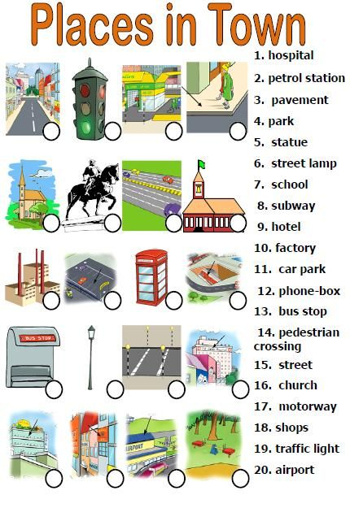**Where can you buy these things? Match them with the shops**

Some aspirin a newsagents’s

A dictionary a supermarket

Pens and paper a department store

Food and drink a stationer’s

Clothes, bags a bookshop

A magazine a chemist’s

**6. Complete the crossword with shops and places in a town.**

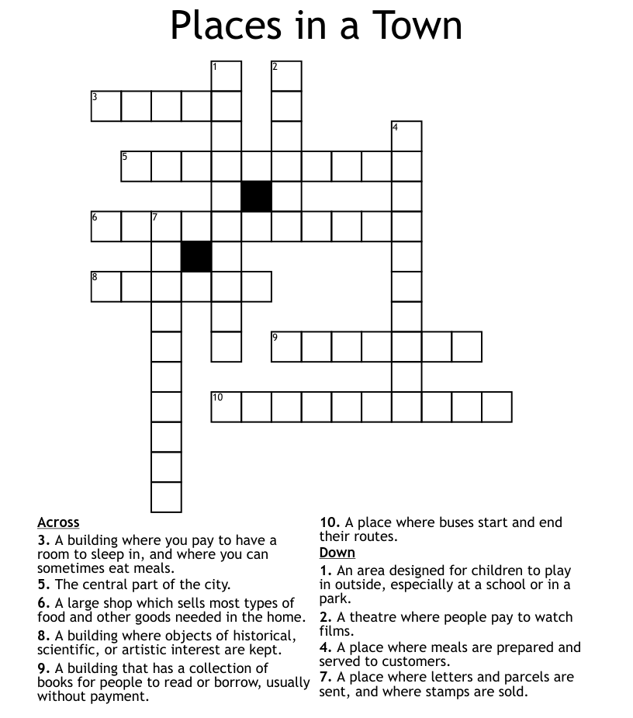

**7. Name the prepositions.**

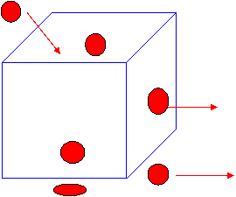

**8. Choose the correct variant.**

1. I can swim, but my brother **can / can't** .

2. My sister **can't / can** ride her bike to school, but I can't.

3. You **can / can't** borrow my computer, it is not a problem.

4. I **can / can't** see Sofia. Look! She is over there.

5. We **can / can't** hear the music. Please turn it up.

6. I **can / can't** do this science homework. It's too hard

**9. Put each sentence into the correct order.**

1. ? / the / you / piano / play / Can 

2. go / . / swimming / can / We = 

3. can't / I / . / Spanish / speak / = 

4. she / to / ? /  his / party / Can / come = 

5. good / take / She / . / photos/ can = 

6. They / watch / can't / . / football / the / match = 

**UNIT 4. PEOPLE**



**1. Give the opposites**

Tall, ugly, rich, happy, fat, old, dark, long, beautiful, big, confident, friendly, awful, teacher, mother, his, cold, smart, expensive.

1. **Read and translate the text**

**My** **Friend**

I have many friends. My best friend is Peter. He is sixteen. Now he is a student of a college. He is a good student because he **studies hard**and is very **diligent.**He wants to become a good specialist and he is**interested in** computers. He often helps me with my English lessons and I'm **grateful**to him for that.

Now I want to tell you about his **appearance.**He is **rather tall**and **strong.**He has an oval face, **straight**nose, **dark - brown hair,** blue **eyes** and a nice smile, people find him good - looking.

Peter goes in for sports. He plays football and basketball well.

We made friends with Peter when his family moved to our house. We have very much **in common:**we like the **same**music, we **both like** reading, in general my friend is a very interesting person: he is **intelligent** and **well-read**. Peter is **honest** and **kind.** I can fully **rely on** him and **trust**everything to him. Peter has a great **sense of humour** and I like to spend my free time with him.

**3. Translate the words in bold from the text**

**4. Choose one of the pictures and describe a person on it**

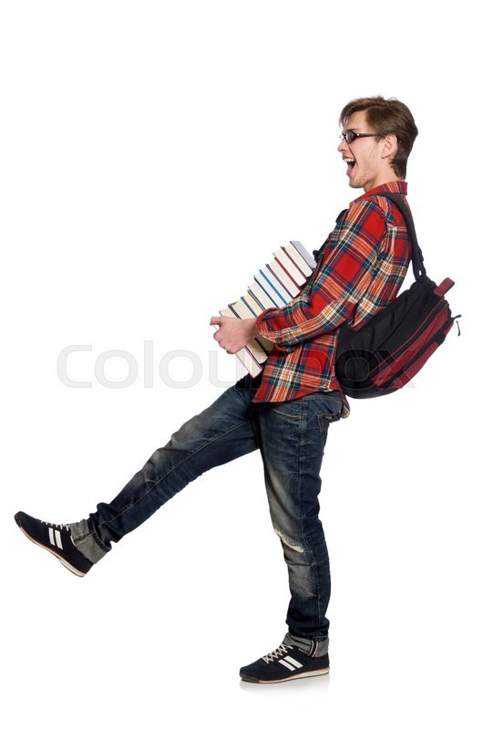



**5. Change the words in italics with possessive pronouns.**

1. This is *Jack’s* brother. 2. This is *Susan’s* nephew. 3. This is *Bob and Dick’s* father. 4. This is *my and my sister’s* granny. 4. This is *Boris’s* niece. 5. This is *Mary’s* sister-in-law. 6. These are *Henry’s* parents. 7. These are *Betty’s* grandparents. 8. This is *my and my brother’s*  grandpa. 10. This is *Richard’s* stepson. 11. These are *John and Nelly’s* children. 12. This is Mrs. Green’s daughter. 13. These are *the Greens’* grandchildren. 14. This is *my and my stepsister’s* family. 15. This is *William’s* cousin.

**6. Use the verbs in Present Simple.**

1. My sister (to get) up at eight o’clock.

2. She (to be) a school – girl. She (to go) to school in the afternoon.

3. Jane (to be) fond of sports. She (to do) her morning exercises every day.

4. For breakfast she (to have) two eggs, a sandwich and a cup of tea.

5. After breakfast she (to go) to school.­­­­­­­­­­­­­­­­­­

6. It (to take) him two hours to do his homework.

7. She (to speak) French well

**7. Translate into English using the verbs in Present Indefinite.**

Мой дядя инженер. Он встаёт в семь часов. Он умывается, одевается и завтракает. После завтрака он идёт на работу. Он работает в институте. Он любит свою работу. Он женат. Его жена врач. Oна работает в больнице. Сын моего дяди ученик. Он ходит в школу. В школе он изучает английский язык.

**UNIT 5. WORK**

**1. Match the jobs with the picture**

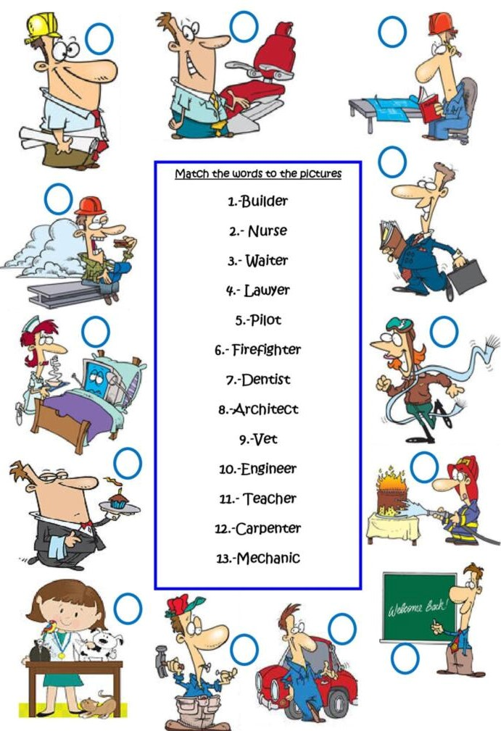**2. Tell who works here**

Hospital, university, office, shop, factory, newsagent’s, restaurant, school.

**3. Read the text and translate**

**MY PROFESSION IS A TEACHER.**

At the moment we have a lot of professions, but after much thought I chose a profession that I want to devote my life. This profession is a teacher of primary school.

In my opinion, the teaching profession is one of the most important professions for society, as it provides the formation of the student's personality, the formation of his moral ideals and behaviors, helps to open the way to a successful future. At the same time, it is one of the most difficult professions, as it requires endurance, stress resistance, the desire for self-development, the ability to find a common language with children. It seems to me that only a person who truly loves children will be able to work at school.

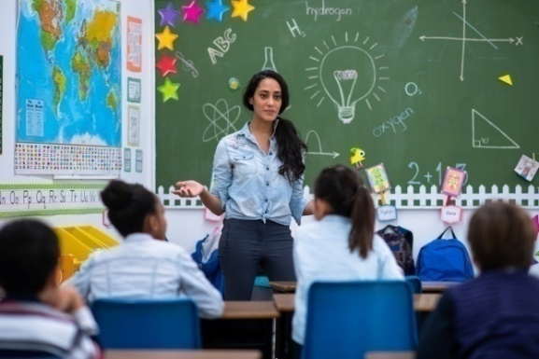 In my opinion, the teacher should be kind, open, caring, understanding. A teacher should have maximal authority and minimal power.

My first teacher, Natalia Alexandrovna, is a teacher who is highly talented and loves her profession. She is kind, fair, sincere, caring. She taught us to grow up smart, kind, responsive, honest people. Natalia Alexandrovna taught us to write, read, count, see the beauty around us. She was a strict but fair teacher, tried to help everyone.

Primary school teacher opens up a huge and interesting world for children. How much new and exciting to learn children in primary school: about plants, animals, objects, learn to read, write and count. In order to become a highly qualified teacher, you need to master more than one school subject. Future teachers need to learn Russian language, literature, mathematics, basics of teaching, human physiology and anatomy, history, geography and psychology. So I diligently study at the Teachers Training college now.

A teacher cannot be a person who does not love children. Children are different, and teachers always need to be able to find an approach to each child. The teacher is also a good psychologist who patiently can explain a new topic, listen and advise how to act in a given situation.

My dream is to become a teacher, to be objective, fair, kind and honest. Every child is an individuality to which you need to choose your "key". I really want to support children who have some problems: lack of parental attention, isolation, problems of communication with peers. After all, helping them, I will help the future society to form self-confident and happy people.

1. **Answer the questions:**

Why did you decide to be a teacher of primary school?

What qualities should a good teacher have?

What are the difficulties of teaching career?

1. **Make sentences negative and questions**

She finishes wok at 9. We play basketball on Sunday. She cleans the flat in the evening. I go to the gym at 6 every day. They get up at 12 at the weekends. I go shopping every Sunday. Nick dries his hair every morning. I like checking e-mails at work. Natasha work from Monday to Friday. She watches TV after work. Children swim in the river in summer. Sam likes his new boss. The secretary makes phone calls in the office. They invite us to work abroad. We have lunch at work. Doctors finish their work at 5. My brother works in a bank. I wash people’s cars. We listen to the news in the morning. My daughter studies Art in college. We like getting up early.

**8. Make sentences in Present Simple using adverbs of frequency: always, never, often, usually, sometimes, seldom.**

**UNIT 6. LEISURE. ACTIVITIES**



**1. Read the text.**

**Leisure time**

Everybody sometimes has a free time. Somebody prefers only to sleep in their leisure time, but most of us prefer to do a great number of interesting things. It may be reading, various types of sport games, watching TV, listening to music and so on. If we have a few days or a week we prefer to go to the attractive places.

As for me my free time is devoted to reading. I like to read books about other countries, another times and another worlds. Also I read books about history of our country. Besides reading I like to do physical exercises. My friends and I often gather together and play basketball, football or other active games. But my favourite hobby is travelling. Usually I travel in summer and often it is a trip to the south, to the warm sea. I think all people must have other occupations besides their basic work, because it extends the boundaries of the familiar world and teaches us something new about people and things.

**2. Give Russian equivalents of the following words and word combinations:**

Free time, leisure time, to prefer, to do things, weekend, gather, favourite hobby, occupation, boundary, to be devoted to, to the south, familiar world.

**3. Answer the questions:**

1) What do people prefer to do in their free time?

2) Do pupils and students have much leisure time?

3) How do you spend your free time?

**4**. **Complete with *have got / has got*. 5. Insert «have» / «has».**

1. The child  …….. a new beautiful toy. 1. ….. her parents got five sons?

 2. They …… eight beautiful flowers. 2. ….. the dog got a puppy?

3. Ann …… a nice black piano. 3. …..  Sue got friends?

4. You …… two beds in your room. 4. …… your sisters got toy elephants?

5. The woman …… a very nice dress. 5. …… the bird got corn?

6. Tim ….. three bananas. 6. …… Ben got a new schoolbag?

7. I …… seven cousins. 7. …… the table got  four legs?

8. Diana and George …..  four children. 8. …… the boys got bicycles?

9. Jane  …….  two  uncles. 9. …… our friends got a new CD?

10. We …….   five English books. 10. …… those boys got  balls?

**6.Make negative and interrogative.**

1. Mary has got a long green skirt. 2. The dog has got a big bone.

3. You have got a nice sister. 4. My niece has got a husband.

5. Henry and Mark have got a grandmother. 6. Alice has got  a  father.

7. The man has got a car. 8. They have got three little dolls.

9. I have got green apples. 10. The  cat has got a little fish.

**7. Put the words in the correct order**

1. got , the dog , how , many , puppies , has ?

2. you , got , a , have , camera ?

3. has , who,  TV set , got , a ?

4. hasn`t , Sue , a , pencil ,why , got ?

5. his , what , has , brother , got ?

6. your , children , many , parents , got , how , have ?

7. brother , got , a , her , blue , has , ruler .

8. haven`t  , got  , bicycles ,  they .

9. homework , got , Dima , hasn`t .

10. many , got  , their , have , friends , toys .

1. **Insert can/can’t**

1. They _____ find what is wrong. 2. We _____ meet tomorrow if you want. 3. I _____ remember lyrics. 4. It’s really dark here, I _____ see anything. 5. You _____ clean your room. 6. A baby _____ talk. 7. You _____ be happy. 8. Sorry I _____ today. 9. You _____ pay me now. 10. You _____ park your car here, it’s forbidden.

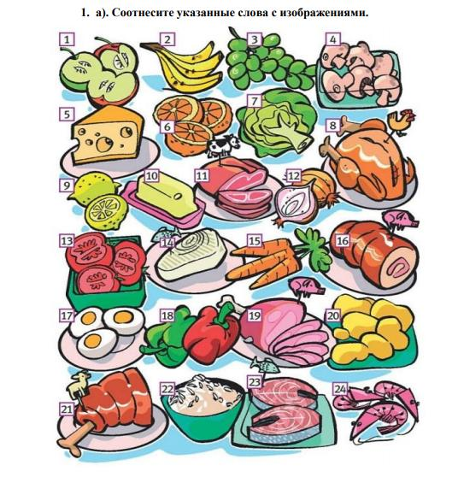**UNIT 7. FOOD**

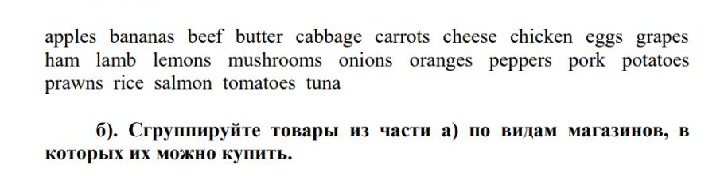

**2. Circle the odd one out.**

*1*prawn crab fish chicken shellfish

2  egg butter cabbage milk cheese

3  chips pasta potatoes fruit juice rice

4  toast jam beef marmalade cereal

5  tea coffee mineral water bacon cola

6  apple cabbage mushroom broccoli

7  sausage tomato beef lamb pork

8  pear onion orange melon banana

**3. Read the text**

**SHOPPING**

People do shopping almost every day. Big supermarkets are self-service shop. Customers can buy all the necessary foodstuffs there: bread, milk, meat, fish, grocery, sausage, sweets, vegetables and fruit. When customers come into the shop, they take a food basket and choose the products they want to buy. When they put everything they want into the basket they come up to the cashier’s desk. There is a computer with a laser scanner that reads and sums up the prices on paced goods at the cashier’s desk. The saleswoman tells how mach to pay. The customers pay the money and leave the shop.

At the grocer’s you can buy sugar, tea, coffee, salt, pepper, ham, bacon, sausages, frankfurters and so on. Bread is sold at the baker’s, meat at the butcher’s. We go to the greengrocer’s for vegetables and fruit. Cakes and sweets are sold at the confectioner’s. When we want to buy clothes, we go to men’s and ladies clothes shop. We buy boots and shoes at the footwear shop. We buy jewelry at the jeweler’s. We buy books at the book-seller’s.

Some shops may have many departments. These shops are called departments stores or supermarkets. Supermarkets are self-service stores with departments for different food products. Supermarkets sell thousands of food products: meat, fresh fruits and vegetables, dairy products, canned groceries, bakery items, frozen foods. Some supermarkets also have seafood and alcohol. Supermarkets are popular because they save time, have low prices and variety of products in one place.

1. **Complete the table**

|  |  |
| --- | --- |
| At the grocer’s we can buy |  |
| At the baker’s we can buy |  |
| At the butcher’s we can buy |  |
| At the greengrocer’s we can buy |  |
| At the book-seller’s we can buy |  |

**5. Fill in “some” or “any”**

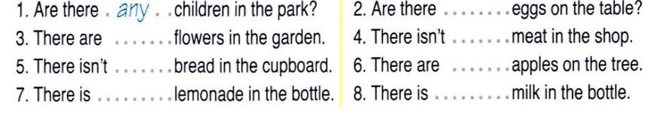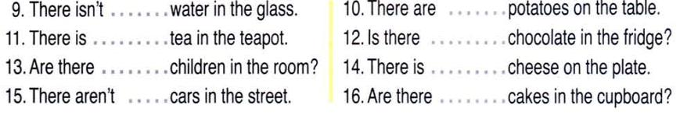

**6. Fill in Many, much, a lot of**

1. I have got ______________ friends.
2. I see ___________ cars in the street.
3. Have you got _________ books?
4. We don’t have __________ books at home.
5. In the park you can see _________ trees.
6. We don’t have _________ apple trees in the garden.
7. Do not drink _________ coffee in the evening.
8. There is __________ snow in winter in Russia.
9. We don’t get __________ snow in winter.
10. Children must drink __________ milk.
11. They have ____________ horses in the farm.
12. Do you see ________ cars in the street?
13. Have you got __________ sweets in the pocket?
14. You must drink __________ juice.
15. We must not eat __________ sweets.
16. There is __________ bread on the plate.
17. I don’t have __________ water in the glass.
18. You can see __________ sheep in the field.
19. Do you read ___________ books?
20. In my room I have not __________ pictures.
21. In my classroom we have _______ pictures.
22. My friend has got ____________ pencils.
23. Can you see ________ animals in the zoo?
24. There isn’t _________sugar in the tea.
25. You can see ____________ flowers in the field.
26. They don’t eat __________ fruit in winter.
27. Is there ____________ money in your pocket?
28. I have got ___________ pens in my pencil box.
29. Frank got ____________ toys for his birthday.
30. Do you see ____________ people in the street?

**7. Read the sentence in Present Simple and transform it to Past Simple.**  
example: Tom usually gets up at 7.30. Yesterday he *got up* at 7.30.

|  |
| --- |
| 1. Tom usually wakes up early. |
| 2. Tom usually walks to work. |
| 3. Tom is usually late for work. |
| 4. Tom usually has a sandwich for lunch. |
| 5. Tom usually goes out in the evening. |
| 6. Tom usually sleeps very well. |

**8. Make sentences negative.**

We opened the window. We asked a question. I looked at him. My brother married her. I changed my clothes. There was an expensive dress I the shop. He moved to Moscow.

**UNIT 8. HOME**

**1. Translate the words**

|  |  |  |
| --- | --- | --- |
| 1. house  2. home  3. flat  4. door  5. living-room  6. floor  7. window  8. bedroom  9. children’s room  10. kitchen  11. study | 12. mirror  13. bookcase  14. wardrobe  15. cupboard  16. bed  17. wall  18. bookshelf  19. curtains  20. microwave oven  21. refrigerator | 22. bathroom  23. hall  24. balcony  25. furniture  26. sofa  27. armchair  28. carpet  29. table  30. vacuum cleaner  31. sink |

**2. Complete the table with the furniture.**

|  |  |  |  |
| --- | --- | --- | --- |
| Hall | Living-room | Dining-room | Bedroom |
|  |  |  |  |
| Children’s room | Study | Kitchen | Bathroom |
|  |  |  |  |

**3.Fill in the missing letters.**

|  |  |
| --- | --- |
| 1. L_v_ng-room  2. B_droom  3. Ch_ldr_n’s room  4. W_rd_ob_ | 5. K_tch_n  6. B_t_room  7. H_ll  8. B_l_on_ |

**4. Guess the word**

|  |  |
| --- | --- |
| 1. diwnow  2. marchira  3. bucproda  4. balet  5. mriror  6. bokoseca | 7. fureurnit  8. darebowr  9. tarcep  10. blosokfeh  11. tucrasin  12. ftorregierar |

**5.Match the room with the activity we do there.**

|  |  |
| --- | --- |
| 1.The study is …  2. The bedroom is …  3. The sitting-room is …  4. The bathroom is …  5. The kitchen is …  6. The dining-room is …  7. The children’s room is ...  8. The hall is … | 1. a place to sleep 2. a place to work 3. a place to cook 4. a place to relax 5. a place to eat 6. a place to leave coats 7. a place to wash 8. a place for children |

**6. Read and translate the text.**

**The House I Live in**

This is a three – storey brick building in the suburb of the city. There is a large garden all round it. In front of the house there is a lawn with beautiful flowers.

Ours is a comfortable three – room flat on the second floor. The staircase of the central entrance leads to it.

Here is our sitting room. It is a quite big room with two windows. Light curtains hang over the windows. We have a sofa, a round table in the center of the room, a sideboard near the wall, armchairs, some chairs and a television set on a special stand. You can see an electric lamp over the table. The floor is covered with a carpet. In this room we have our meals.

From it a door opens into our bedroom. There are two beds, two bedside tables, a dressing table with a mirror and a wardrobe in it. On a bedside table stand an alarm clock and an electric lamp.

And this is the study. It is a small and light room. There are two book-cases near the door. In front of the book – cases stands a large writing table. To the left from the desk there is a sofa with a large cushion on it. There are also two chairs and an armchair in the study.

Besides we have a kitchen and a bathroom. In the kitchen there are: a cooker, a fridge, a sink, a cupboard, a table and chairs. The bathroom has a bath with a shower and a washbasin. Above the basin there is a mirror.

**7. Ask 5 questions to the text using the construction *is there/are there.***

|  |
| --- |
|  |
|  |

**8**. **Write a letter to your friend about your flat or house.**

**9. Put the words in the correct order**.

a. holiday / go / to / on / aren’t / going / they

b. worry / it / rain / . / going / don’t / is / to / not

c. tell / answer / you / the / going / not / I’m / to

d. aren’t / going / we / listen / to / to / him

e. her / homework / isn’t / to / going / do / tonight / she

**UNIT 9. SEASONS**

1. 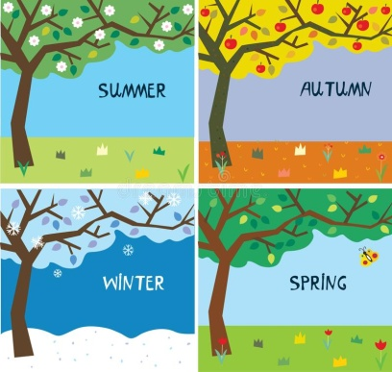**Read the text and answer the questions**

Winter, spring, summer and autumn are the seasons of the year. December, January and February are the winter months The weather is cold, usually it snows. The days are short and the nights are long. The rivers and lakes freeze and we can go skating and skiing. March, April and May are the spring months. It is a very nice season. The weather is fine, it is warm. There are many green trees in the streets in the parks and in the yards. Sometimes it rains but usually the sun shines brightly. The birds return from the hot countries and build their nests. June, July and August are the summer months. It is hot or warm. The days are long and the nights are short. There are many nice flowers in the parks and squares in the summer. The pupils do not go to school, they have summer holidays. June is the first month of summer. We have the longest day and the shortest night in the year on the 21st-22nd of June. July is the middle month of summer. It is hot and sun shines brightly. The sky is blue and cloudless. August is the last summer month some times it is cold in August, but there are many mushrooms, berries and fruits. September, October and November are autumn months. The weather is changeable. It often rains. You can see yellow, red, brown leaves everywhere. It is time to gather the harvest.

How many seasons are there in a year? Name them

What season is it now?

What’s the weather like in autumn? Spring? Summer? Winter?

What are the spring months?

What’s your favorite season? Why?

What do you usually wear in winter? Summer? Spring? Autumn?

**2. Guess the riddles**

This is the season when fruit is sweet,   
This is the season when school-friends meet.

This is the season when vegetables grow,  
I come to the garden and make water flow.

The wind is blowing, Blue sky is seen,  
The snow is falling. The trees are green.  
When all is white, The world looks new and gay,  
Short day and long night. Because grey winter’s gone away.

The flowers are blooming,  
The sun is shining.  
The rains are few,  
The sky is blue.

It is cool. The weather is changeable. It often rains. The days become shorter and the nights become longer. The birds prepare to fly to the South. One can see yellow, red, brown leaves everywhere. It is time for gathering harvest.

**3. Match the words with the picture**

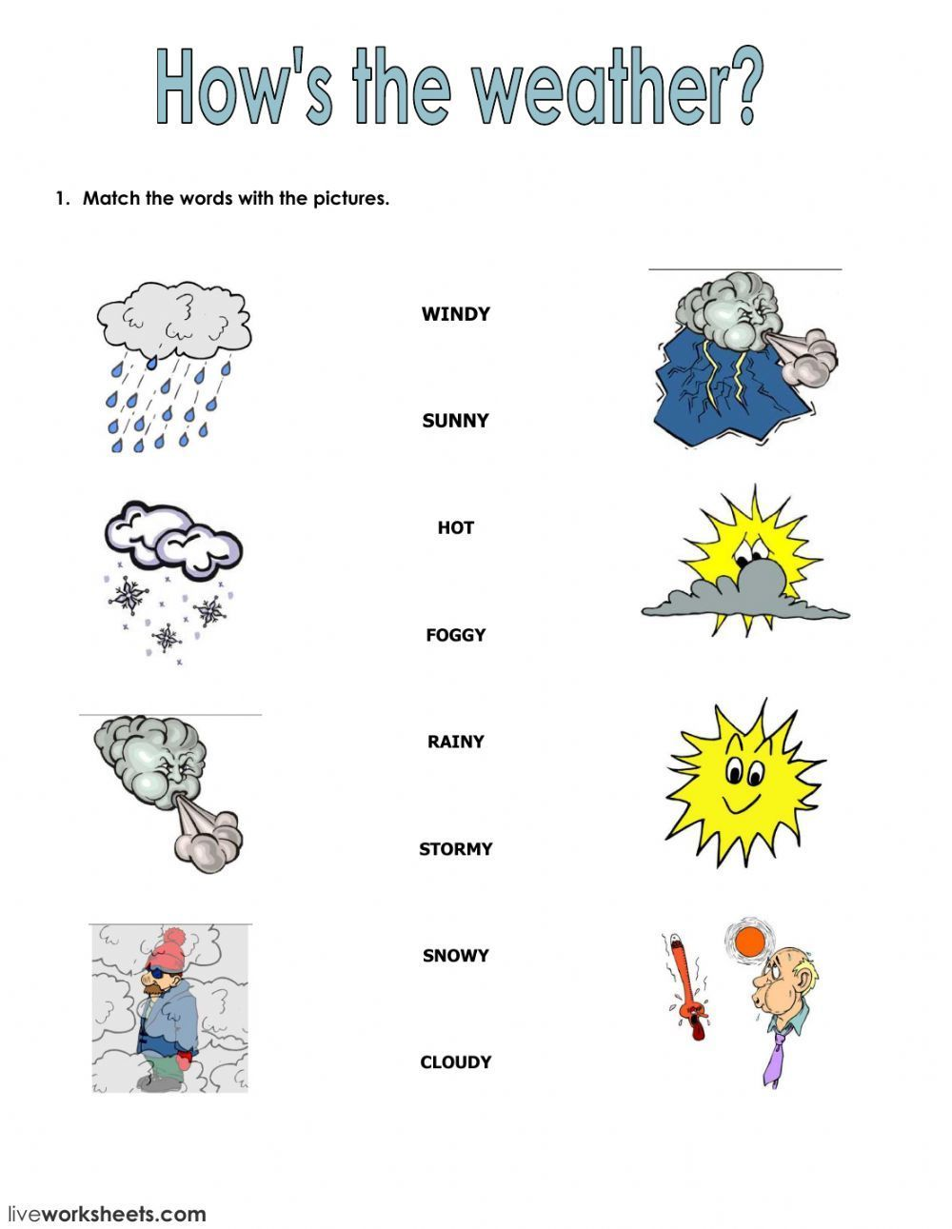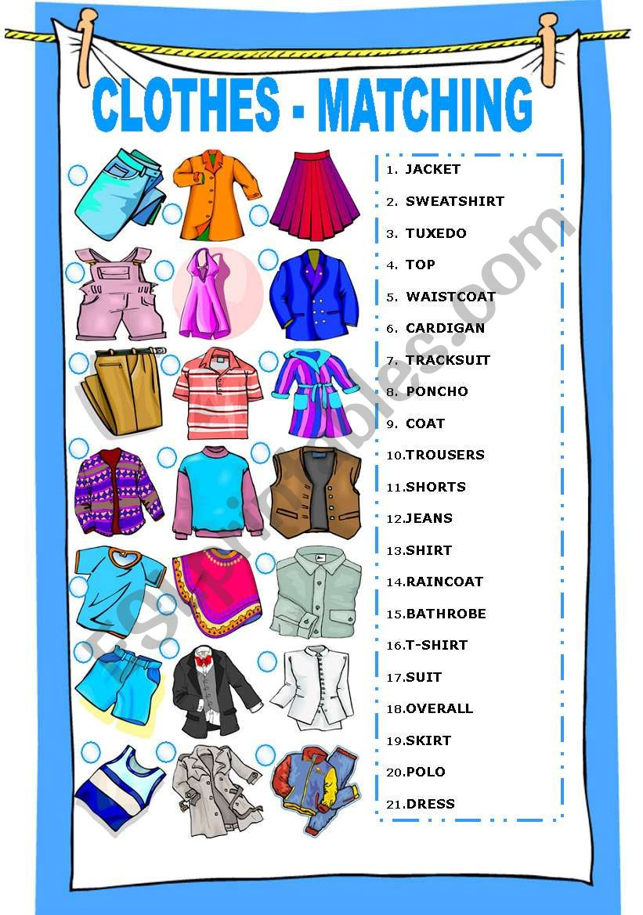

**4.Open the brackets using Present Continuous**

1. Where you ( go )?- I (go) to the supermarket.

2. The Browns (come ) to see us tonight. Go and buy some sweets and a cake.

3. Where is Ann? She (do) the flat.

4. What you (do)? –I (draw) pictures for my little son.

5. You (watch) TV? – No, I’m not.- Switch it on at once! They ( show ) your dancing group.

6. Tomorrow we’ll have a party. What dress you (wear )? – I don’t know yet.

**5. Put the verbs in brackets into the “Present Simple” or “Present Continuous”.**

1. He often ___________ ( go) to the cinema.

2. They _______________ (watch) TV at the moment.

3. John is outside. He ___________ ( wash) the car.

4. Nina usually _________ ( drive) to work.

5. Father __________(lie) on the sofa now.

6. Claire __________ (not/ like) pizza.

7. She (write) letters to her mother every week

8. Listen. The telephone (ring).

9. Tim (study) a new language every year.

10. We always (spend) the summer in York.

11. In summer we usually (go) to the seaside.

12. Look at Tom. He (ride) a horse.

13. He often (watch) birds in autumn.

14. Don’t ask me now. I (write) an exercise.

15. She usually (watch) television in the evening.

16. I (play) the piano every day.

**6. Choose the correct form Present Continuous & Present Simple**

1. It sometimes (snows/is snowing) here in April. 2. It (snows/is snowing) now. 3. Every morning mother (cooks/is cooking) breakfast for us. 4. It is 8 o’clock now. Mother (cooks/ is cooking) breakfast. 5. Every day father (leaves/is leaving) the house at half past eight. 6. Now it is half past eight. Father (leaves/is leaving) the house. 7. We often (watch/are watching) TV. 8. Now we (sit/ are sitting) in armchairs and (watch/are watching) TV. 9. Sometimes Mike (does/is doing) his lessons in the evening. 10. Look at Mike. He (does/is doing) his lessons. 11. It often (rains/is raining) in September. 12. It (rains/is raining) now. 13. Every day the family (has/is having) tea at 5 o’clock. 14. It is 5 o’clock now. The family (has/is having) tea.

**7. Translate into English.**

Зачем вы это объясняете? Все это понимают. Ты всегда пишешь левой рукой? Мы уезжаем отдыхать в Испанию. А знаешь, о чем я думаю? Конечно нет. В этих краях осенью часто идет дождь. Ты видишь их? Вон они сидят за тем столиком. На завтрак я ем кашу. Семья Смитов сейчас проживает в гостинице. Мы живем в Москве. Торопись, автобус идет. - Том играет в футбол каждое воскресенье.

**8. Choose the correct form. Present Continuous & Present Simple & Past Simple**

1) It sometimes (rains/ is raining) in winter here.  
2) It never (snows/ snowed) in Africa.  
3) What’s the weather like today? — It (is raining/ rains).  
4) It (rains/ rained) all day yesterday.  
5) It is cold but it (isn’t snowing/ doesn’t snow).  
6) It didn’t (rain/ rained) last month.  
7) Cold winds (blow/ blows) in winter.

**UNIT 10. CULTURE**

**1. Read and translate the text.**

The Oxford Advancer Learner’s Dictionary of Current English by Hornby gives us the following definition of the notion “art”. “”Art” is the creation or expression of what is beautiful, especially in visual form. Drawing, painting, sculpture, architecture, literature, music, ballet belong to the fine art”.

Russia is a country that can rightfully boast its artistic and cultural traditions, its art galleries attract huge crowds of tourists from all over the world. St. Petersburg is a precious stone in the crown of Russian cities. The Hermitage is famous all over the world for its valuable rare collections of canvases and other art objects covering a span of about seven hundreds years and comprising masterpieces of by Leonardo da Vinci, Titian, Raphael, Rembrandt, and Rubens. The collections illustrate the art of Italy, Spain, Holland, Germany, France, Britain, and Sweden. The West – European Department also includes a fine collection of European Sculpture. People come to admire the collections of tapestry, precious textiles, weapons, ivory, pottery, porcelain and furniture as well.

Speaking about art one should not forget about music, especially classical music. Outstanding Russian composers make the whole world admire their music. One can find a man, who does not know Pyotr Ilyich Tchaicovsky, Michail Glinka, Nikolai Rimsky-Korsakov – the prominent composers of 19th century, and Sergey Rachmaninov, Sergey Prokofiev and Dmitriy Shostakovich. It was Glinka who laid the foundation for modern Russian music; his music expressed the temperament of Russian people. His two best known operas “Ivan Susanin” and “Ruslan and Ludmila” were based on Russian folklore and historical legends. The most famous ballets “Swan Lake”, “The Sleeping Beauty”, “The Nutcracker” and not less famous operas “The Queen of Spades”, “Eugene Onegin” are still excellently staged and performed not only in Russian but also in many greatest theatres in the world.

Russia is world famous for its literature. The “golden age” of Russian literature began in the 19th century when such outstanding masters of letters such as Alexander Pushkin, Lermontov, Gogol, Turgenev, and Dostoyevsky created their immortal masterpieces. Alexander Pushkin, the father of Russian Literature was the author of more than 700 lyrical poems. He wrote also the volumes of dramatic works, short stories, made adaptations of Russian fairy-tales.

Russia is famous for its architecture. The real jewel of architecture is the Moscow Kremlin with its cathedrals, towers and red brick walls. Just outside the Kremlin walls stands St. Basil’s Cathedral, one of the world most astonishing buildings with 8 domes of different designs and colours. St. Petersburg has great number of real masterpieces of architecture of different styles and is definitely worth visiting and being admired.

**2. Put ten questions to the text**

**3. Make comparative and superlative form of the adjectives**

|  |  |  |
| --- | --- | --- |
| **положительная** | **сравнительная** | **превосходная** |
| heavy |  |  |
| good |  |  |
| short |  |  |
| bad |  |  |
| little |  |  |
| wide |  |  |
| beautiful |  |  |
| thick |  |  |
| wonderful |  |  |
| clean |  |  |
| hard |  |  |
| interesting |  |  |
| hot |  |  |
| warm |  |  |

**4. Open the brackets using the adjectives in comparative or superlative form**

1  I like living in the country. It's a lot ..... (peaceful) than the city  
2  I felt very  ill last week, but I'm slightly.......(good) now.  
3  I can't hear you. Could you speak a little..... (loud) please?   
4  Steven is..... (tall) boy in the basketball team.  
5  This computer is very old. I need something..... (modern).

1. **Complete the table with degrees of comparison**

|  |  |  |
| --- | --- | --- |
|  | larger |  |
|  |  | nicest |
| White |  |  |
| Rich |  |  |
|  |  | smallest |
| Red |  |  |
| Big |  |  |
|  | nicer |  |
|  |  | finest |
| Cozy |  |  |
|  | happier |  |
| comfortable |  |  |
|  | more interesting |  |
| Difficult |  |  |

**6. Open the brackets using degrees of comparison.**

1. Jill’s a far________ (intelligent) person than my brother.
2. Kate was the_________ (practical) of the family.
3. Greg felt __________ (bad) yesterday than the day before.
4. This wine is the ____________ (good) I’ve ever tasted.
5. Jack was the________ (tall) of the two.
6. Jack is the__________ (clever) of the three brothers.
7. If you need any ___________ (far) information, please contact our head office.
8. The sinking of Titanic is one of _____________ (famous) shipwreck stories of all time.
9. Please, send the books back without_________ (far) delay.
10. The deposits of oil in Russia are by far the __________ (rich) in the world.
11. Could you come a bit _______ (early) tomorrow?
12. I like this song _________ (well) than the previous one.

**7. Compare two pictures**

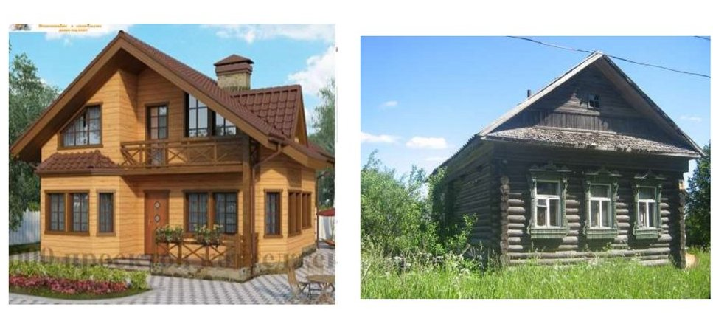

**UNIT 11. MUSIC**



**1. Read the text and then write an essay about your favourite music style or a performer.**

**Music in Our Life**

Music is very important in our life. We cannot live without music. Nowadays many people enjoy music as their hobby. People listen to music everywhere: at home, in the bus, in the street, in the shops.

There are so many kinds of music in our life. For example, rap and pop music, rock and alternative music, industrial and disco music, drum & bass, classical music.

Different people like different music. The scientists say that they can define your character if they know what music you like. For example, they suppose that people who listen to rock music are very clever. Music shows people’s soul and nature.

*Classical music* is often associated with the music of the past. This music includes opera, chamber music, choral pieces, full orchestra. Scientists proved that listening to classical music has a beneficial effect on the physical and the moral state of a man. This music always makes you to have emotions or associations, as though reading a good book and, together with its heroes live among them. Classical music also enhances the memory of a man.

Classical music includes the works of Wolfgang Mozart and Ludwig van Beethoven. Benjamin Britten was a master of vocal music of all kinds.

*Rock music* is the kind of music many young people listen to. In rock songs you can notice many important problems that thrill youth. It is primarily based on older musical styles with a heavy focus on guitar, drums, and powerful vocals. One of the earliest and most famous performers of rock was Elvis Presley, who shocked the world with his suggestive dancing and powerful music. Another hugely successful and popular rock music group was the Beatles. The Beatles were a legendary English rock band, which was established in 1959 in Liverpool. The group consisted of John Lennon, Paul McCartney, George Harrison and Ringo Starr.

*Rap music* is a modern musical style where the singer speaks or shouts the words in time to music with a steady beat. This type of music often deals with the hardships of inner-city life. Rap songs are often known for their focus on controversial themes, such as gang violence. They often express their political and social views, and they may discuss their own lives or even write love songs.

*Pop music* is a genre of popular music. The popular group was Abba in XX century. It was formed in 1973 in Sweden. Abba’s cheerful tunes made them international pop stars. Pop music is breathtaking and full of energy. When people listen to pop music it makes them remember happy times and forget the problems of everyday life. It helps them to relax when they are tired. Texts of pop songs devoted to personal experiences, emotions: love, sadness, joy.

1. **Guess the word by its definition.**

- the main song in a film

- to get music from the Internet to computer

-a person who writes music

-a song for 2 people

- a main person in a band who sings

- part of a song which is repeated

- words of a song

- Pop music from South America

- A group of people who play music together

1. **Match the type of music to the dictionary definitions:**

*Rap, opera, jazz, punk, heavy metal, blues*

1. ______Rock music that is played in a fast, loud, and aggressive way. It was very popular in the late 1970s.

2. ____A style of music invented by black American musicians in the early part of the twentieth century. It has a strong rhythm and often involves improvisation. Famous musicians include Louis Armstrong, Billie Holiday and Miles Davis.

3. _______A type of music in which singers don’t sing but speak the words quickly, in a rhythmic way.

4. _______It’s like a play in the theatre, but people sing the words.

5. _______A type of very loud rock music, with lots of guitars and a strong beat.

6._______A type of music developed by black American musicians in the southern United States. It is slow, often sad, and with a strong rhythm.

**4. Make the sentences negative and interrogative.**

Peter has been ill for a week. He has been there several times. They have spent in England three years. We have been friends since our childhood. I have already had lunch. She is too thin. She has been on a diet for a month.

**5. Fill in with “ yet” , “ ago” , “ ever”, “ last night”, “ for”, “ since”.**

1. My father went to Spain two days _________ .

2. He has known her ___________ 1999.

3. She hasn’t finished her work ____________.

4. Have you ________ seen an elephant?

5. We went to bed at 10 o'clock ____________.

6. He has been in Madrid _____________ ten years.

**6. Translate the sentences**.

1)  Who can answer my question? 2)  Nobody could translate this text. 3)  He ought to do this task at once. 4)  Must I attend this meeting? – No, you needn’t. 5)  You should have shown your notes to the teacher. 6)  I asked him, but he wouldn’t listen to me. 7)  They should visit her, she is in the hospital. 8)  Last summer we would often go to the country. 9)  Your son can do this work himself. 10) Would you tell me the way to the station? 11) Your friend might have informed us. 12) May I leave for a while? – Yes, you may. 13) She should be more attentive at the lessons. 14) You needn’t come so early. 15. We have to stay at home. 16. Who is able to do this work?

**7. Translate using *can (could).***

**1**. Я умею говорить по-английски. 2. Мой папа не умеет говорить по-немецки. 3. Ты умеешь гово­рить по-французски? 4. Я не могу выпить это молоко. 5. Ты умел плавать в прошлом году? 6. В прошлом году я не умел кататься на лыжах. 7. Не могли ли бы вы мне помочь? Я не могу перевести это предложение. 9. Где тут можно купить хлеб? 10. Твоя бабушка умела танцевать, когда была молодая? — Да, она и сейчас умеет.

**8. Underline the correct form of the modal verb.**

1. You *must / should / shouldn’t* be 18 before you can drive in Spain.
2. You *don’t have to / mustn’t / shouldn’t* go to bed so late. It's not good for you.
3. You *don’t have to / mustn’t / shouldn’t* wear a school uniform in most Spanish state schools.
4. You *must / mustn’t / need*n’t come. I can do it without you.
5. You *don’t have to /must / mustn’t* copy during exams.
6. You *don’t have to /mustn’t / shouldn’t* be very tall to play football.
7. *You must /mustn’t / needn’t* be a good writer to win the Pulitzer Prize.

**9.** **Fill in *must / may / can / should***

1. You ______not smoke here.
2. ______you hear that strange noise?
3. He______come today or tomorrow.
4. My little brother______ count to ten.
5. This incident ______have serious consequences.
6. You ______have a valid permit to enter.
7. I have some free time. I ______ help her now.
8. I ______ drive Susan's car when she is out of town.
9. ______ I have a glass of water?
10. Anyone ______ become rich and famous if they know the right people.
11. You ______ go to this party. It's very important.
12. Bird ______ be known by its song.
13. He is coming here so that they ______ discuss it without delay.
14. It's late. You ______ go to bed.
15. He ______ have told me about it himself.

**СПИСОК ИСПОЛЬЗУЕМОЙ ЛИТЕРАТУРЫ**

* 1. In Company Second Edition, Elementary Student's Book with CD-Rom. Саймон Кларк - Оксфорд, Макмиллан, р. 240, 2012
  2. Planet of English: учебник английского языка для учреждений СПО / Г. Т. Безкоровайная, Е.А. Койранская, Н.И.Соколова, Г.В.Лаврик. электронный учебно-методический комплекс английского языка для учреждений СПО. - М., Академия, 2015. -255 с.
  3. Virginia Evans – Jenny Dooley Upstream. Elementary A2 Workbook student’s book - Express Publishing, p. 97, 2014
  4. Качалова, Ксения Николаевна, Израилевич, Ерухим Евелевич. Практическая грамматика английского языка.- СПб.: Базис, Каро, 2012.-608 с.
  5. Соколова Н.И. Planet of English: Humanities Practice Book. Английский язык. Практикум для специальностей гуманитарного профиля СПО. электронный учебно-методический комплекс английского языка для учреждений СПО. — М., Академия, 2014. - 89 с.
  6. <https://agendaweb.org/verbs/modals-exercises.html>
  7. <https://www.perfect-english-grammar.com/modal-verbs-exercises.html>
  8. <https://www.english-4u.de/en/grammar/present-perfect-simple.htm>