Урок английского языка в 7 классе УМК «Spotlight»
Тема урока:
«Environmental Problems»
Учитель: Моренова Ольга Владимировна

МАОУ «Образовательный центр №4 им . героя Советского Союза В.П.Трубаченко г.Вольска Саратовской области»

1.Hello!
(Учитель предлагает детям выбрать карточки, чтобы занять свои места.)
Before we start come here and choose the card for you.
These are the cards, come and choose the cards.
So, look here. If you have a green card, please, sit here. If you have a yellow card , please, sit here.
Дети определяются со своими местами , организуются вокруг столов
Stand up, please.
My name is Olga Vladimirovna and today I’m your English teacher.
Well, let’s look at the rules of our lesson.
Учитель демонстрирует детям плакат с правилами и зачитывает их вслух перед классом.
Rule# 1- Be active.
Rule #2 Be positive.
Rule #3 Speak English only.
Rule #4 Raise your hand if you want to answer.

Are they clear?
Дети отвечают: Yes/ Yes, they are.
Accepted. Very nice.
Take your seats, let’s stars our lesson.
II. Этап целеполагания.
Учитель ставит познавательную задачу, опираясь на фотографии по теме урока и используя метод ведения проблемного диалога.
Look at the pictures of nature in our city. We live in the beautiful place, don’t we? Слайд 1 -Yes, we do.

And now compare them with these pictures. Do you want to live in such place? Слайд 2 -No, we don’t.
How do you think what we are going to discuss at the lesson?
-We will discuss environmental problems on our planet.
Right! So, the topic of our lesson today is Environmental problems. We will talk about them.

What is the aim of our lesson? Look at the screen. This is the question, but the words are mixed. Can you make the question?
You ’re welcome!
Can to we What save do Earth the ?
What can we do to save the Earth?
Teacher: OK. Yes. You are right. Thank you very much.
So this is the aim of our lesson to answer the question : What can we do to save the Earth?
And now look here, these are the steps of our lesson. What do you think we will do?

We will learn | We will read
We will speak | We will listen
We will play | We will present
We will write
Yes, what else?/ What do you usually do at the lesson?
OK, yeah, for sure. Right.
At last we will present some new information.
These are the steps of our lesson.
3. So, let’s start with the first step. Let’s learn.
I will give you new phrases. So please put them in front of you.
Now you will see the pictures, your task is to guess what it is and raise the phrase. OK?
Are you ready? Let’s start.
What’s this?
Учитель показывает слайды с картинками и называет фразы, дети показывают карточки- фразы.
OK
Cut down trees | Acid rains | Drop litter
Environmental problems | Plant trees and flowers | Pick flowers in the wild nature
Air pollution | Make fire in the forest | Recycle rubbish
Dump waste into rivers | Take care of animals | Fish and animals species dying
 | Global warming | Water pollution
Loss of natural habitats | Clean out ponds and rivers
Когда все фразы показаны, озвучены и повторены, учитель предлагает:
Now let’s repeat all the phrases.

And now I want you to be active and energetic. Stand up, please.
Stand up, please.
4.Лексика- физминутка.
Here you will see the pictures and the phrases. If the phrase is correct, please hands up. If the phrase is incorrect – hands to the sides. Ready?
Учитель включает картинки с сопровождением фразами и озвучивает. Дети делают соответствующие движения.
Well, I see you have very strong memory, very good. Take your seats.
5. Упражнения на отработку лексики.
We have revised our phrases very good, and now I offer you to do an exercise.
These are envelopes for you. Open them, please, and take out your worksheets.
OK. Look at them attentively and find ex #1.

Your task is to divide them into positive and negative. You can mark positive phrases with green pen, and negative with red pen. Is the task clear? OK, you can start. You have 2 minutes.
Cut down trees + | Acid rains + | Drop litter +
Keep cities and forests clean | Plant trees and flowers √ | Pick flowers in the wild nature +
Air pollution + | Make fire in the forest + | Recycle rubbish √
Dump waste into rivers + | Take care of animals √ | Fish and animals species dying +
 | Global warming + | Water pollution
Loss of natural habitats + | Clean out ponds and rivers√

So, the time is over. Are you ready to answer? Very well. Who wants to start?
Дети дают ответы, учитель поощряет словами. Затем предлагает проверить, включает слайд, где фразы правильно отмечены.
And now I want you to choose the phrases which are «ecological problems».
Cut down trees +
Environmental problems + | Acid rains + | Drop litter +
Air pollution + |  | Pick flowers in the wild nature +
Dump waste into rivers + | Make fire in the forest +
Toxic fumes + |  | Fish and animals species dying +
Loss of natural habitats + | Global warming +

Well done!
6. And now it’s time to listen and read the text about environmental problems.
Now let’s learn some more about ecological problems. And let’s have a listening task.
Please, open your textbooks at page 76. Ex.# 2. Here you have the text. Have you find it? And you need your pens. Have you got pens? OK.
So, you see the gaps there. The task for you will be to listen to the text and to fill in the gaps.
Now our task is to check everything and let’s do it together.
Please exchange your sheets of paper clockwise.
And to check your work, you need your book. Go to page 76, ex.2.
There you should find the best word A, B or C and check your friend work.
Put a plus if the word is correct, and put a minus if it’s wrong, OK?
___ When you are ready give the work back to your friend, OK?
So, look at your work:
Who has NO mistakes, raise your hands, please.-Well done, excellent mark for this task.
Who has ONE mistake? - It’s also very good.
Who has 2 mistakes?- OK? You worked hard and it’s very nice.

After That I want you to answer the question:
What ecological problems are described in the text?

Try to be attentive and put your answers in your worksheets, NOT in your books OK? Let’s start.
Keys:
1b away
2a but
3c also
4c some
5 a our
Учитель:
Now its time to answer the question – What environmental problems are mentioned in the text?
Answer: toxic fumes, acid rain, air, water and soil pollution.
T.: Can we solve these problems on our own?
No , we cant. The government must pass a law to ban factories from polluting the nature.
7.But everyone can do at least one useful thing for our environment. How do you think, what it is? It is a common problem in every place -on the streets, on the beaches, in the forests, on the water, etc.-?
Yes, you are right. It’s litter. Bad-mannered people drop litter everywhere.
And we should keep our areas, our towns clean.
Lets play a game.
I have a box. You will come here and take out a card with a picture on it. Your task is to define-can we recycle this things or just carry them to the landfill.
Is it clear? Let’s start.
(на доске изобраения двух корзин, дети прикрепляют карточки –по соответствующим категориям : переработка- свалка)
Well done!
8. Творческое задание, как итоговый продукт.
We have known a lot about environmental problems. And for the next task I want you to become ecologists, experts.
Your task is to work out the set of rules. This rules will help people to save our planet clean and beautiful.
You should make up sentences using modal verbs from the screen:
You should | You shouldn’t
You must | You mustn’t

Every team has got a sheet of paper, a set of felt-tip pens, wax pencils, a set of pictures, a glue stick.
I hope you are full of ideas, and will use your imagination and decorating skills.
Create a leaflet or a poster and represent your team work.
Is the task clear? You may start.
You have … minutes .
Cut down trees + | + | Drop litter +
+ | Plant trees and flowers √ | Pick flowers in the wild nature +
Pollute the air + | Stay fires in the forest + | Recycle rubbish √
Dump waste into rivers + | Take care of animals √ | Fish and animals species dying +
Keep our cities, forests and rivers clean |  | Pollute the water
Destroy natural habitats + | Clean out ponds and rivers√
Example:
You should plant more trees and flowers. You mustn’t cut down trees.
Ребята работают, по истечении времени представляют свои проекты, работы вывешиваются на магнитную доску.
9. Подведение итогов.
OK, you did your best and could present your creative works there.
And now let’s come back to our steps, please.
Have we learnt today?________________________________________________________________________________________________________________________________________________________________________________________________
Can we answer the question:
How can we save the Earht?
OK, thank you.
10. And the last task for you is to give a feedback about our lesson.
You have a set of stars, raise them to answer.
Be attentive, choose the right colour giving an answer.
- Do you like the lesson?
Green - yes
Red – no
blue- I ’m not sure/
Yellow- I don’t care.
- Do you understand all new words and phrases?
Green - yes
Red – no
blue- I ’m not sure/
Yellow- I don’t care.
- Do you feel comfortable?
Green - yes
Red – no
blue- I ’m not sure/
Yellow- I don’t care.
OK, thank you.
11. Homework
Now please look at your homework for the next lesson.
The task for you will be ex. 2 page 84,.
And if you are really creative, you may create poster about ecological problems in our hometown. If you want, you may do it.
12. Saying gratitude
So you worked very hard so you have excellent mark for this lesson.
Thank you very much, I liked to work with you a lot. I wish you good luck and great success in school life.
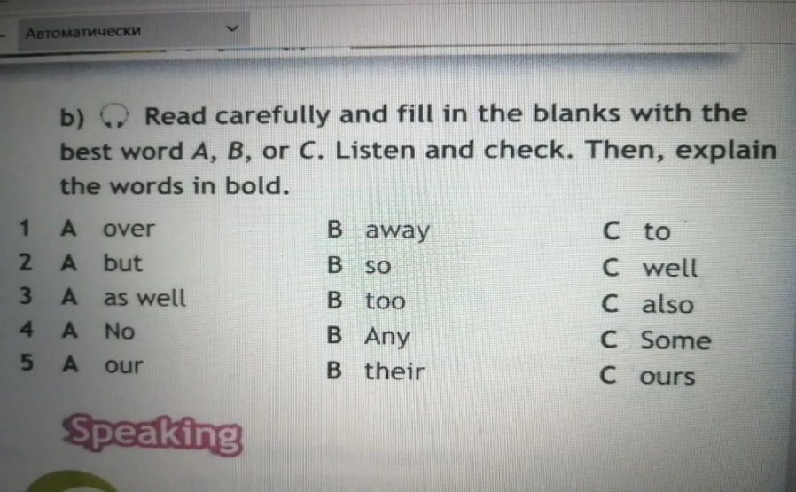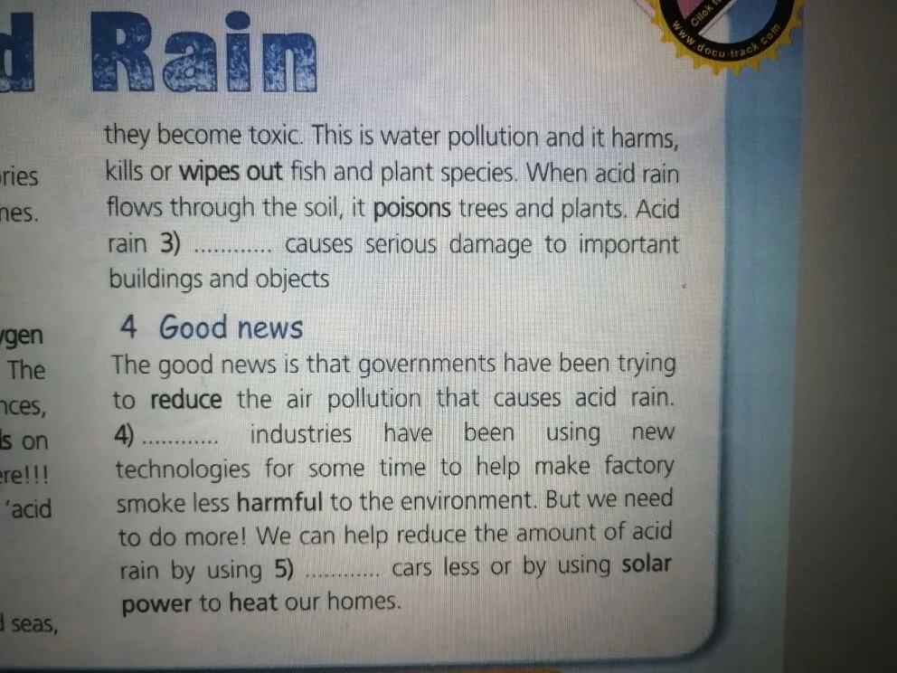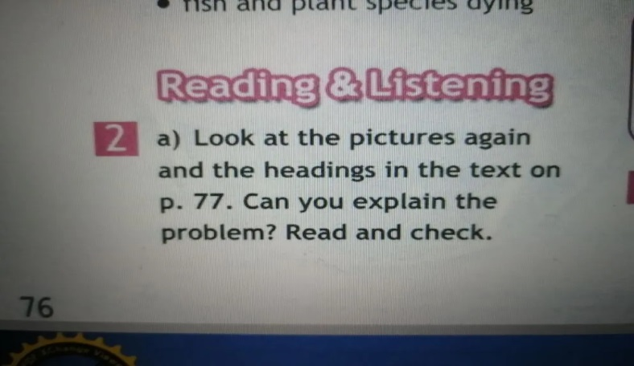
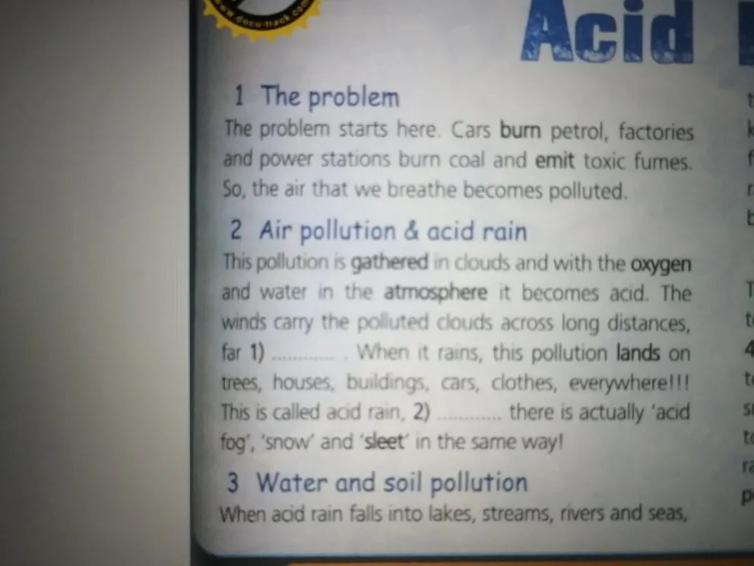

Приложение.
Worksheet
Task 1
1)Your task is to divide the phrases into positive and negative. You can mark positive phrases with plus, and negative with minus. You have 2 minutes.
Cut down trees | Acid rains | Drop litter
Water pollution | Plant trees and flowers | Pick flowers in the wild nature
Air pollution |  | Recycle rubbish
Dump waste into rivers | Take care of animals | Fish and animals species dying
Keep cities and forests clean | Global warming
Loss of natural habitats | Clean out ponds and rivers
2) Write out the phrases which mean «ecological problems».
____________________________________________________________________________________________________________________________________________________________
Task 2
a)Text #2 page76. Listen to the text and fill in the missing words.

1)
2)
3)
4)
5)
b)Answer the question
Which ecological problems are mentioned in the text?
_______________________________________________________________________________________________________
Task 3
Your task is to work out the set of rules. This rules will help people to save our planet clean and beautiful.
You should make up sentences using modal verbs
You should | You sholdn’t
You must | You mustn’t
and phrases
Cut down trees + | + | Drop litter everywhere +
+ | Plant trees and flowers √ | Pick flowers in the wild nature +
Pollute the air + | Stay fires in the forest + | Recycle rubbish √
Dump waste into rivers + | Take care of animals √ | Stay fish and animals species alive √
Keep our cities, forests and rivers clean√ |  | Pollute the water+
Destroy natural habitats + | Clean out ponds and rivers√

Example:
You should plant more trees and flowers. You mustn’t cut down trees.
Make a leaflet or a poster using these sentences.

